Prepared for:

**Federal Communications Commission**

**CMS Alliance to Modernize Healthcare**  
**Federally Funded Research and Development Center**

**Contract No. 75FMC18D0047**

**Task Order No. 273FCC19F0144**

ACE Direct Platform Release Documentation

User Guide

Version 6.0

July 23, 2021

The views, opinions, and/or findings contained in this report are those of The MITRE Corporation and should not be construed as official government position, policy, or decision unless so designated by other documentation.  
  
Approved for Public Release; Distribution Unlimited. Case Number 21-2211.

© 2021 The MITRE Corporation. All rights reserved.

Record of Changes

| Version | Date | Author/Owner | Description of Change |
| --- | --- | --- | --- |
| 1.0 | November 4, 2016 | The Health FFRDC | Version 1.0 for release to Sponsor |
| 1.1 | February 17, 2017 | The Health FFRDC | Version 1.1 for release to Sponsor |
| 2.0 | November 1, 2017 | The Health FFRDC | Version 2.0 for release to Sponsor |
| 2.1 | May 24, 2018 | The Health FFRDC | Version 2.1 for release to Sponsor |
| 3.0 | October 26, 2018 | The Health FFRDC | Version 3.0 for release to Sponsor |
| 3.1 | April 9, 2019 | The Health FFRDC | Version 3.1 for release to Sponsor |
| 4.0 | July 1, 2020 | The Health FFRDC | Version 4.0 for release to Sponsor |
| 4.1 | November 30, 2020 | The Health FFRDC | Version 4.1 for release to Sponsor |
| 5.0 | February 5, 2021 | The Health FFRDC | Version 5.0 for release to Sponsor |
| 6.0 | July 23, 2021 | The Health FFRDC | Version 6.0 for release to Sponsor |

1. Executive Summary

The Federal Communications Commission (FCC) Telecommunications Relay Service (TRS) Center of Expertise (COE) Project promotes the Commission’s goal to foster innovations that advance functionally equivalent telecommunications. Toward that end, the project ensures that the TRS employs improved technology for persons who are d/Deaf,[1] Hard of Hearing, DeafBlind, and/or have speech disabilities. The FCC has embraced a research-based approach to achieve this goal by engaging the Health Federally Funded Research and Development Center (Health FFRDC), operated by The MITRE Corporation (MITRE), to conduct independent engineering assessments that promote and demonstrate TRS’s functional equivalence.

The Health FFRDC is independently assessing voice telephone services, video access services, and Internet Protocol (IP)-based captioning technology; improvements to TRS efficiency; solutions for direct communication between people with communication disabilities and other telephone users; and the effectiveness, efficiency, and consumer response to current and future approaches for delivering TRS.

At the FCC’s request, the Health FFRDC developed a Direct Video Calling (DVC) Auto-Routing Proof of Concept (POC) in support of the FCC’s Accessible Communications for Everyone (ACE)[2] program. This DVC auto-routing platform enables direct calling from d/Deaf or Hard of Hearing individuals to an American Sign Language (ASL)-trained agent within the organization’s call center. The agent handles the call using a video-capable phone with real-time video connection. To demonstrate the capabilities of DVC, the FCC, and the Health FFRDC have further advanced the original auto routing POC into a call center platform for 2 to 20 Agents. This new DVC platform is called ACE Direct.

Implementing the Direct Video Calling platform provides critical benefits toward achieving functionally equivalent telecommunications:

* **Improved Communications** – DVC improves privacy and decreases misrepresentation, which improves efficiency, effectiveness, and productivity.
* **Career Opportunities** – Employing native ASL users to handle customer service video calls expands hiring opportunities. Executive Order 13548 (July 2010) directed federal agencies to increase employment opportunities for people with disabilities.
* **Simple Implementation** – The technology to implement a DVC system is readily obtainable, affordable, and easy to set up.
* **Secure Communications** – With proper configuration, agencies can use high-speed broadband and their own internal networks without compromising security or contending with barriers created by firewalls.
* **Maintain ADA Compliance** – DVC ensures compliance mandated by the Americans with Disabilities Act.
* **Cost Savings** – Replacing three-way interpreted calls with two-way direct communication saves money by minimizing the need for repeat calls due to miscommunication and/or misunderstanding.

As part of this effort, the Health FFRDC developed and documented requirements and features, including user stories and associated use cases. The Health FFRDC also configured, tested, and integrated video relay services (VRS) provider endpoint video devices with the ACE Direct platform. Detailed configuration and source code files are available for download to improve solutions to support the community. The public can download or clone these files at <https://github.com/FCC/ACEDirect>.

New features in ACE Direct version 6.0 include the following:

* **Call Monitoring** – The Agent portal now allows for an Agent to passively monitor an ongoing call between another Agent and a consumer.
* **Call Transfers** – The Agent portal now supports both cold and warm call transfers between Agents.
* **Call Recording** – The Agent portal now supports recording of a call. Call recordings can be used for training purposes or to record behavior that may concern the agent.
* **File-Sharing Enhancements** – ACE Direct now supports a more secure file sharing between the Agent and Consumer. An open-source virus and malware scanner (ClamAV) has been integrated into the ACE Direct file sharing function.
* **Multi-Party Captions and Chat** – The Agent and Consumer portals will display captions and chat in multi-party calls.

Table of Contents

Contents

Record of Changes ii

Executive Summary iii

Table of Contents v

List of Figures vii

List of Tables x

1. Introduction 1

1.1 Background 1

1.2 Purpose and Scope 2

2. Overview of Direct Video Calling and ACE Direct 3

2.1 DVC Is an Alternative to Traditional Relay Calls 3

2.2 Open-Source Development to Promote Community Involvement 3

2.3 Conceptual System Overview 3

2.4 ACE Direct Components and Technology Features 6

2.5 Highlighted User Stories 12

2.6 Agent Portal 14

2.6.1 Logging into ACE Direct 14

2.6.2 Left Navigation Panel 15

2.6.3 Video and Real-Time Text Communications 36

2.6.4 Agent Portal Header 38

2.6.5 Video Relay Service 39

2.7 Kuando Busylight Visual Ring Indicator and Agent Status 39

2.7.1 Agent Status 40

2.7.2 Kuando Busylight Light Configuration 40

2.7.3 Lightserver 41

2.8 Consumer Help Center 42

2.8.1 Submit a Complaint 42

2.8.2 Use Real-Time Text Chat 47

2.8.3 Leave a Videomail 48

2.8.4 Consumer Multi-Party Calls 49

2.8.5 Consumer Screen Sharing 49

2.8.6 Consumer File Sharing 49

2.9 Management Portal 52

2.9.1 Management Dashboard 52

2.9.2 Call Detail Record Dashboard 53

2.9.3 Agent Report 55

2.9.4 Videomail Dashboard 57

2.9.5 Hours of Operation 58

2.9.6 Call Blocking 59

2.9.7 Agent Management 62

2.10 Identity and Access Management 64

2.10.1 Login Screen 65

2.10.2 User Dashboard 67

List of Figures

Figure 1. Notional Diagram for ACE Direct Platform 4

Figure 2. Screenshot of Agent Portal Login 14

Figure 3. Screenshot of Agent Portal 15

Figure 4. Agent Portal Call Options When In-Call 15

Figure 5. Screenshots of the Agent Statuses 16

Figure 6. Dialpad for Outbound Calling 17

Figure 7. Dialpad Warning 17

Figure 8. Caption Settings 18

Figure 9. Screenshot of In-Call Options 18

Figure 10. Agent Preferred Language 18

Figure 11. Call History 19

Figure 12. Call History Log 20

Figure 13. Screenshot of an Agent Multi-Party Call 20

Figure 14. Agent Enable/Disable Screenshare Option 21

Figure 15. Agent Screen Sharing Options 21

Figure 16. Screenshot of Agent Screen Sharing 22

Figure 17. Agent Choosing a File to Share 22

Figure 18. Screenshot of Agent Sending Files 23

Figure 19. Agent Sent File Confirmation 23

Figure 20. Agent Sent File Error 23

Figure 21. Screenshot of Agent Selecting Download File Option 24

Figure 22. Screenshot of Agent Right Panel 24

Figure 23. Screenshot of Agent Status 25

Figure 24. Agent Status Information 25

Figure 25. Screenshot of Agent Videomail Mailbox 26

Figure 26. Screenshot of Videomail Playback 26

Figure 27. Screenshot of Videomail Options 27

Figure 28. Screenshot of Callback Option in Videomail Mailbox 27

Figure 29. Agent to Agent Chat Option 28

Figure 30. Agent to Agent Chat Message Window 28

Figure 31. Agent to Agent Chat Message Received 29

Figure 32. Agent Sending Broadcast Message 29

Figure 33. Agent Broadcast Confirmation Message 30

Figure 34. Agent Broadcast Message Received 30

Figure 35. Agent Portal Shortcuts Menu 31

Figure 36. Agent Shortcuts Cleared 31

Figure 37. Call Recording Button 32

Figure 38. Call Recording Activated View 32

Figure 39. Call Recording Playing 33

Figure 40. Call Transfer Option 33

Figure 41. Call Transfer Types 34

Figure 42. Transfer Call Ringing Popup 34

Figure 43 Wrap Up Notification After Transferring a Call 35

Figure 44. Call Monitoring Option 35

Figure 45. In-Call Options While Monitoring 35

Figure 46. Screenshot of Full Screen Video Mode 36

Figure 47. Screenshot of Sample Captioning on the Agent Portal 37

Figure 48. Screenshot of User Chat Window 38

Figure 49. Screenshot of Call Duration and Assistance Button 38

Figure 50. Screenshot of Agent Profile 39

Figure 51. Screenshot of VRS Information 39

Figure 52. Screenshot of Kuando Busylight Light Configuration Page 40

Figure 53. Screenshot of Kuando Busylight Default Color Scheme 41

Figure 54. Lightserver GUI 41

Figure 55. Screenshot of Consumer Help Center 42

Figure 56. Consumer Incorrect Number Message 43

Figure 57. Consumer Portal Language Option 43

Figure 58. Consumer Portal Language List 44

Figure 59 Consumer Portal Language Set to Spanish 44

Figure 60 Consumer Portal Language Changed 44

Figure 61. Screenshot of Consumer Complaint Form 45

Figure 62. Consumer Video Chat Window 46

Figure 63. Screenshot of Consumer Video Chat In-Call Options 46

Figure 64. Screenshot of Sample Captions on the Consumer Portal 47

Figure 65. Agent Real-Time Chat Window 47

Figure 66. Screenshot of Ready to Record 48

Figure 67. Screenshot of Videomail Recording in Progress 48

Figure 68. Screenshot of Consumer Screen Sharing 49

Figure 69. Consumer File Share Option 50

Figure 70. Consumer File Share Send File Option 50

Figure 71. Consumer File Sent Confirmation Message 51

Figure 72. Consumer File Sent Error Message 51

Figure 73. Screenshot of Consumer Download File and Confirmation Message 51

Figure 74. Screenshot of Management Dashboard 52

Figure 75. Screenshot of Call Detail Record 54

Figure 76. Agent Management Report Option 56

Figure 77. Agent Management Report Date Selection 56

Figure 78. Agent Management Custom Report Option 57

Figure 79. Top Ten Report View 57

Figure 80. Screenshot of Videomail Dashboard 58

Figure 81. Screenshot of Hours of Operation Page 59

Figure 82. Call Blocking Menu 59

Figure 83. Blocking a Call 60

Figure 84. Call Blocking Information Pop-Up Menu 60

Figure 85. Unblocking a Phone Number 61

Figure 86. Unblocking a Call Confirmation Message 61

Figure 87. Update Blocked Call Pop-Up 62

Figure 88. Screenshot of Agent Management Page 62

Figure 89. Screenshot of Add New Agent Pop-Up 63

Figure 90. Screenshot of Update Agent Pop-Up 64

Figure 91. Screenshot of Agent Bulk Deletion Pop-Up 64

Figure 92. Screenshot of Login Screen 65

Figure 93. Screenshot of Retrieve Your Username 66

Figure 94. Screenshot of Reset Your Password 66

Figure 95. Screenshot of Register Your Account 67

Figure 96. Screenshot of User Dashboard 67

Figure 97. Screenshot of Basic Info Tab 68

Figure 98. Screenshot of Update Password Tab 69

Figure 99. Screenshot of Security Questions Tab 69

Figure 100. Screenshot of User Dashboard 70

Figure 101. Screenshot of Logout Screen 70

List of Tables

Table 1. ACE Direct Components 4

Table 2. ACE Direct Version History 6

Table 3. ACE Direct Features 10

Table 4. Highlighted User Stories for ACE Direct 13

Table 5. Agent Status 41

Table 6. Lightserver GUI Data Elements 43

Table 7. Call Detail Record Column Definition 55

# Introduction

The Federal Communications Commission (FCC) Telecommunications Relay Service (TRS) Center of Expertise (COE) Project promotes the Commission’s goal to foster innovations that advance functionally equivalent telecommunications. Toward that end, the project ensures that the TRS employs improved technology for persons who are d/Deaf, Hard of Hearing, DeafBlind, and/or have speech disabilities. In this document, “d/Deaf” describes individuals who are deaf in the audiological sense as well as those who identify as culturally Deaf.

The Centers for Medicare & Medicaid Services (CMS) Alliance to Modernize Healthcare Federally Funded Research and Development Center (Health FFRDC) accelerates innovation by connecting people and data to reinvent health systems, enhance the care experience, and protect and promote the health and well-being of all Americans. Sponsored by the Department of Health and Human Services (HHS) and operated by The MITRE Corporation (MITRE), the Health FFRDC serves as an objective advisor to all HHS organizations and other federal agencies with health and human services missions.

## Background

The FCC has embraced a research-based approach to achieve this goal by engaging the Health FFRDC to conduct independent engineering assessments that promote and demonstrate TRS’s functional equivalence. As part of the Accessible Communications for Everyone (ACE) program, the Health FFRDC independently assesses voice telephone services, video access services, and Internet Protocol (IP)-based captioning technology; improvements to TRS efficiency; solutions for direct communication between people with communication disabilities and other telephone users; and the effectiveness, efficiency, and consumer response to current and future approaches for delivering TRS.

In continuing pursuit of the Commission’s goal to advance functionally equivalent telecommunications, the Health FFRDC developed ACE Direct, an open-source call center platform that supports Direct Video Calling (DVC) for 2 to 20 Agents. Implementing ACE Direct in a corporate/government production environment requires customization to ensure adherence to corporate/government practices and policies related to security, system configurations, cloud services, and availability.

The FCC encourages government agencies and private businesses to make DVC part of their call center strategy because it offers significant gains for providing functionally equivalent telecommunications, including the following:

* **Improved Communications** – DVC improves privacy and decreases misrepresentation, which enhances efficiency, effectiveness, and productivity.
* **Career Opportunities** – By employing native American Sign Language (ASL) speakers to handle customer service video calls, DVC expands hiring opportunities. Executive Order 13548 (July 2010) directed federal agencies to increase employment opportunities for people with disabilities.
* **Simple Implementation** – The technology to implement a DVC system is readily obtainable, affordable, and easy to set up.
* **Secure Communications** – With proper configuration, agencies can use high-speed broadband and their own internal networks without compromising security or contending with barriers created by firewalls.
* **Maintain ADA Compliance** – DVC ensures compliance mandated by the Americans with Disabilities Act (ADA).
* **Cost Savings** – Replacing three-way interpreted calls with two-way direct communication saves money by minimizing the need for repeat calls due to miscommunication and/or misunderstanding.

The Health FFRDC developed and documented ACE Direct requirements and features, including consumer stories and associated use cases. The Health FFRDC also configured, tested, and integrated video relay service (VRS) provider endpoint video devices using the ACE Direct platform.

## Purpose and Scope

This document presents an overview of the ACE Direct architecture and user stories and describes how to integrate DVC within a current call center workflow to provide an independent, on-demand service.

In addition to this release documentation, detailed configuration and source code files are available to the public at <https://github.com/FCC/ACEDirect> for download and reproduction of the platform to support and promote future platform enhancements.

# Overview of Direct Video Calling and ACE Direct

People who are d/Deaf, Hard of Hearing, DeafBlind, or speech disabled use TRS to communicate with each other and with hearing people over the phone. Since the early 2000s, VRS calls have been the primary way that ASL-fluent consumers access telecommunications. VRS involves the use of third-party communication assistants (CA) as sign language interpreters to place telephone calls. The interpreter translates between ASL and spoken English for the non-signing party. Many people who communicate in ASL use VRS to place telephone calls to customer assistance divisions of government agencies and businesses in the United States every day, but other solutions are available to this community.

## DVC Is an Alternative to Traditional Relay Calls

The FCC’s support of the ACE program includes creating a DVC platform. The ASL Consumer Support Line[3]—the first of its kind in the federal government—allows ASL users to make video calls directly to an agent fluent in ASL. English is not the first language of many d/Deaf, Hard of Hearing, DeafBlind, and speech disabled TRS consumers. One-to-one communication in ASL is most often preferred.

When comparing calls made to the FCC ASL Consumer Support Line with calls placed through VRS, the FCC found that VRS calls were handled on average 33 percent faster, and there was an approximately threefold increase in the number of Consumers who are deaf.Most impressive is that the FCC achieved these results without adding staff to handle the increased call volume.

## Open-Source Development to Promote Community Involvement

ACE Direct is an open-source software platform that offers one option for implementing DVC. Open source promotes universal access via a free license to a product’s design/blueprint and universal redistribution of that design/blueprint, including subsequent improvements to it. The open-source model employs a decentralized model of production. A main principle of open-source software development is that peer production: products, such as source code, “blueprints,” and documentation, are available to the public at no cost.

The FCC encourages government agencies, educational institutions, and others seeking to enhance the lives of citizens who are d/Deaf, Hard of Hearing, DeafBlind, and/or have speech disabilities to adopt and improve on the existing code base to provide additional features, improve the workflow, and introduce new technologies to the open-source ACE Direct platform.

## Conceptual System Overview

The Health FFRDC developed the open-source-based ACE Direct platform for implementation in the Amazon Web Services (AWS) cloud environment. Figure 1 presents a notional view of the architecture of the ACE Direct components from a configuration and programming standpoint.

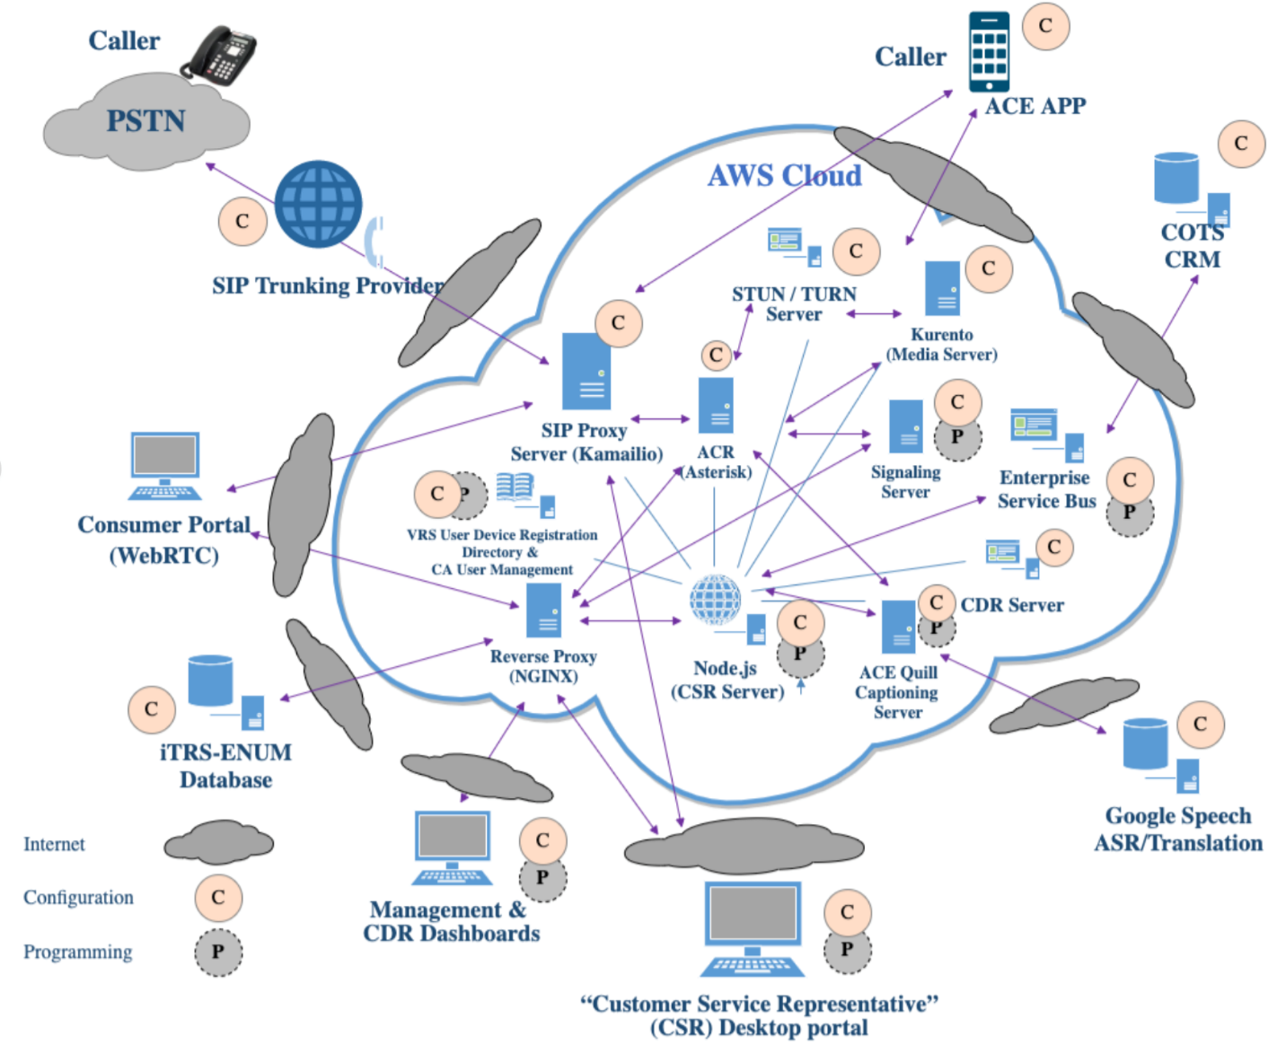

Figure 1. Notional Diagram for ACE Direct Platform

As Figure 1 shows, some ACE Direct components require only configurations (noted as “C”) and other components require both configuration and programming (noted as “P”). Table 1 presents an overview of these components and provides a listing and description of the major components in ACE Direct. Please refer to the *ACE Direct Installation and Configuration Guide* for detailed information about installation and configuration.

Table 1. ACE Direct Components

| Component | Description |
| --- | --- |
| Agent Portal | The Agent Portal provides a user interface to the Agent—the Customer Service Representative (CSR)—for login and conducting DVC services to the ACE Direct Consumers. |
| Open-Source PBX (Private Branch Exchange) | The Asterisk open-source PBX supports direct video communication via both Public Switched Telephone Network (PSTN) and video calls. |
| Captioning Server | The ACE Quill captioning server provides the interface to web-based captioning services and provides speech-to-text capabilities for both the Agent and Consumer portals. |
| Commercial Off-the-Shelf (COTS) Customer Relationship Management (CRM) | To demonstrate integration with a CRM service, ACE Direct connects to the Zendesk Representational State Transfer (RESTful) application programming interface (API) via the Enterprise Service Bus. ACE Direct sends Java Script Object Notation (JSON)-based messages to the RESTful Zendesk API to manage and query customer records. |
| Enterprise Service Bus (ESB) | The ESB provides a generic method to update legacy database systems as well as the diverse number of databases and unstructured data repositories on the market and in use today. ACE Direct ESB integrates with a COTS CRM service (e.g., Zendesk) as a ticketing system for the Agent to document service cases. |
| External Visual Ring Indicator and Agent Status | The Kuando Busylight™ is used as an external visual ring indicator and Agent status instrument. ACE Direct supports both of its models—Alpha and Omega. |
| Identity and Access Management (IADM) | ACE Direct uses the Open Access Management (OpenAM) and Open Identity Management (OpenIDM) components from ForgeRock to:   * Provide secure access to the Agent and Management portals. * Allow self-help features, such as registration and lost password. * Allow a Manager to set the hours an Agent can be active in the system. |
| iTRS-ENUM database | The iTRS (Interstate Telecommunications Relay Service) database maps 10-digit U.S. telephone numbers to IP addresses using the industry-standard ENUM (E.164 Number to Uniform Resource Identifier (URI) Mapping) protocol. VRS providers assign these 10-digit telephone numbers to their customers. |
| SIP Proxy Server | The Kamailio SIP (Session Initiation Protocol) Proxy server provides a single point of entry following Defense-in-Depth principles to create a layer between the ACE Direct environment and the Internet. This enhanced security provides a means to mitigate certain exploits and Distributed Denial of Service (DDoS) attacks. |
| Management Portal | The Management Portal provides Key Performance Indicators (KPIs) that the call center manager can monitor in real time. The Call Detail Record (CDR) Dashboard provides the view and export functions of the Asterisk CDRs stored in its MySQL database. The Report page provides call summary records, charts, and downloadable data. The Videomail Dashboard provides access to all videomails. The Light Configuration page allows configuration of the behavior of the Busylight. The Hours of Operation page configures hours of operation for the call center. The Call Blocking page allows blocking and unblocking of inbound web and provider calls. The Agent Management page maintains ACE Direct Agents. |
| Media Server | The Kurento media server enhances voice, video, and data communication. It also provides advanced calling features such as multiparty calling, screen recording, and more. |
| Node.js | Node.js is an open-source platform that can be used to develop applications and servers. For ACE Direct, the Node.js server contains several services running on ports to support the Agent Portal and other management-related portals, including the Management Portal and Call Detail Record Dashboard. The Node.js server supports the Real-Time Text (RTT) between the Agent Portal and the Consumer Portal. It also provides services for VRS lookup to verify that the phone number is a valid number in the VRS database. |
| Reverse Proxy, Load-balancer, and HyperText Transfer Protocol (HTTP) Cache | NGINX is used as a reverse proxy to only expose HyperText Transfer Protocol Secure (HTTPS)/port 443 and hide internal port number and internal script names to prevent spoofing and hacking by external entities. |
| Consumer Help Center | The Consumer Portal combines form submission with real-time audio, video, and text communication to an Agent. |
| State Management and Key Information Storage | Redis is an in-memory, key-value data storage. It is used as a database to store data previously stored in memory to manage state. |
| STUN Server | STUN (formerly Simple Traversal of User Datagram Protocol (UDP) through Network Address Translation [NAT] Request for Comment [RFC] 3489) is reflexive and identifies if the endpoint is behind a NAT or firewall and determines the public IP address. This helps STUN establish a peer-to-peer connection. |

## ACE Direct Components and Technology Features

The following subsections recount the development history of ACE Direct and the features in its components. Table 2 shows, by version number and release date, the history of ACE Direct and the features added to each version.

Table 2. ACE Direct Version History

| Version | Release Date | Enhancements/Features Introduced |
| --- | --- | --- |
| 1.0 | November 4, 2016 | * The first open-source, omnichannel, auto call-routing contact center platform designed for 2 to 20 Agents * Browser-based interface allowing for remote use by Agents and Managers * A Management Portal for contact center statistics such as calls waiting, calls abandoned, and average hold time. * Video, audio, and RTT communications. * Web Real-Time Communications (WebRTC) technology to facilitate browser-to-browser video communication * Enterprise Service Bus for enterprise data integration * Support for multiple queues: Complaints and General Questions |
| 1.1 | February 17, 2017 | * Call transfer functionality from one Agent to another * Increased character limit in WebRTC RTT implementation * Acceptance of inbound PSTN calls * Data transmission encryption using Transport Layer Security (TLS) and HTTPS throughout the platform * Segmentation of application servers to increase system scalability * Code modifications to improve reliability and scalability |
| 2.0 | November 1, 2017 | * Introduced a “single pane of glass” for the Agent Portal, ensuring all communications occur through the browser * Enhanced system security through: * An identity and access management solution, OpenAM, to manage system access * Universal Resource Locator (URL) masking using NGINX to prevent external cyberattacks * Added an external visual ring indicator (Kuando Busylight) to inform the Agent of an incoming call and others of an Agent’s status * Introduced videomail recording and retrieval * Provided usability enhancements to the Agent, Management, and Consumer portals * Simplified the installation process for quicker installations |
| 2.1 | May 2018 | * Added capability for Managers to modify the contact center’s hours of operations * Added function for Managers to close the contact center in case of emergency * Integration with Zendesk using change data capture (CDC) Software. This permanent feature is configurable during installation. * Developed ACE Direct skinny modes for both the Agent and Consumer screens when a separate CRM system is in use * Established outbound calling from the Agent Portal * User Interface (UI) Enhancements: * Present the Agent’s name to Consumer during a call * Re-style the back button on the Consumer Portal * New dialog to inform Consumers that they are in queue * Clear/enable/disable chat using context (both Agent and Consumers) * Agent option to Return to Away/Return to Ready after a call * Enhancements to the Management Portal UI, including the Agent PIE chart, etc. * Incorporated resizable/movable/profile-able Agent forms * Improved Installation and Operations * Global configuration file to simplify the installation process * Updated installation procedure for global configuration * Consolidated database for both ACE Direct and Asterisk * Created an ACE Direct sample database (DB) (script) for an initial installation * Redesigned ACE Direct/NGINX/OpenAM routing for simplicity and HTTP Strict Transfer Security (HSTS) directive |
| 3.0 | October 26, 2018 | * **Containers** – Containers simplify the overall ACE Direct installation, configuration, and deployment. They improve portability to different environments and add modularity. * **Management Portal Agent Provisioning UI** – The Management Portal Agent Provisioning screen makes it easy for call center managers to provision and maintain Agent users in both OpenAM and ACE Direct. This allows customization of the default Agent accounts. * **Data Logger Utility** – The Data Logger Utility captures and saves log files, trace information, and testing details automatically. This information facilitates troubleshooting interoperability and call quality issues. * **NGINX Custom Error Page** – The NGINX Custom Error Page is a more user-friendly page than the default NGINX error page. This ACE Direct page appears when the system is offline. * **ASL Video On Hold** – This feature allows the call center to display or advertise a custom message to a caller while on hold or after hours * **Customizable ACE Direct URLs** – Customizable ACE Direct URL allow owners, like the FCC, to customize the public URLs to match their corporate name or brand. An example is <https://xyzcorp.org/XYZDirect/agent>. |
| 3.1 | April 9, 2019 | * **SIP Proxy Server** – The SIP Proxy server provides a single point of entry following Defense-in-Depth principles to create a layer between the ACE Direct environment and the Internet. This enhanced security provides a means to mitigate certain exploits and Distributed Denial of Service attacks. |
| 4.0 | May 20, 2020 | * **Captioning** – Automated Speech Recognition (ASR) engine speech-to-text captioning is now available in the Consumer and Agent portals. * **WebRTC Media Server** – ACE Direct now uses a Kurento WebRTC Media Server to enhance and improve ACE Direct’s voice, video, and data capabilities. * **Videomail Enhancement** – The media server implements higher-quality videomail recordings, Interactive Video and Voice Response, and a countdown timer. * **Containerization** – Open AM and Asterisk are now available as Docker containers. * **Agent, Consumer, and Management Portal UI Enhancements** – The web portals have better aspect ratios for video, element locations, element placement, and button sizing. * **Captioning Demo Capability** – ACE Direct now has a captioning preview feature that plays a mock captioning conversation between a Consumer and an Agent. This feature is for demonstration purposes only. * **Multi-Party Calling** – ACE Direct Agents and Consumers can now participate in calls with up to four simultaneous callers on the same call. * **Screen Sharing** – ACE Direct users allow the caller to share their screen with another caller. * **File Sharing** – ACE Direct allow users to share/transfer files from one user to another. |
| 4.1 | October 30, 2020 | * **Call Blocking** – Management portal page enables blocking/unblocking incoming calls from VRS devices and softphones, as well as web calls from the Consumer Portal. * **Call History** – Agent portal dialog to access inbound and outbound call history and place outbound calls * **Videomail Notification** – Popup notifications appear in the Agent portal when the call center receives new videomails. * **Keyboard Shortcuts** – Customizable keyboard shortcuts for actions in the Agent Portal * **Call Statistics Report** – The Management Portal reporting page provides daily call statistics, plots, and the capability to download the data. |
| 5.0 | February 5, 2021 | * **Language Translation** – The Agent and Consumer portals now provide the option to display captions and text chats in languages other than the default English language. The Agent or Consumer must select their preferred language prior to accepting or making a call. * **Agent Auto Away** – The Agent portal now automatically changes the Agent’s status from Ready to Away after missing consecutive inbound calls. The default setting is 3, however, this is configurable. * **Agent to Agent Chat/Broadcast Messaging** – The Agent portal now provides messaging from Agent to Agent or to multiple agents simultaneously. * **Agent Call Totals** – The Management portal now allows the manager to see the total number of calls as part of the Report feature. Also displayed in the Report option is the call data Top 10 States, Top 10 Area Codes, and Top 10 VRS Numbers. |
| 6.0 | July 23, 2021 | * **Call Monitoring** – The Agent portal now allows for an Agent to passively monitor an ongoing call between another Agent and a consumer. * **Call Transfers** – The Agent portal now supports the transferring of calls between Agents. * **Call Recording** – The Agent portal now supports recording of a call. Call recordings can be used for training purposes or to record behavior that may concern the agent. * **File-Sharing Enhancements** – ACE Direct now supports a more secure file sharing between the Agent and Consumer. An open-source virus and malware scanner (ClamAV) has been integrated into the ACE Direct file sharing function. * **Multi-Party Captions and Chat** – The Agent and Consumer portals will display captions and chat in multi-party calls. * **WebRTC In-Call Statistics and FPS Indicator** – The agent portal can retrieve and log WebRTC in-call statistics as a diagnostics tool. New frames per second and packets lost indicators appear on the agent portal during a call. |

Table 3 provides a description of the major features in ACE Direct.

Table 3. ACE Direct Features

| Feature | Feature Description | |
| --- | --- | --- |
| **Agent Portal** – The Agent interface to the Consumer | * Browser-based to allow for remote access * Data transmission is encrypted using TLS and HTTPS * All video and RTT communications are conducted through a single browser * Video display can be set to full screen on command. This is particularly useful when video communication is less than ideal. * Outbound calling using an integrated dialer * Videomails can be viewed and the display sorted on any data fields listed * Videomail callbacks can be made with the click of the mouse * Number of unread videomails displayed * Get Help feature to contact Manager * External visual ring indicator to notify the Agent of an incoming call and others when the Agent is in a call * Support for multiple queues: Complaints and General Questions * Displays the number of calls waiting in the queue * Visibility into the status of other Agents. Useful if Agents are geographically disbursed. * Call duration provided to the Agent while in the call * CRM ticket information and scripts can be integrated into ACE Direct and displayed in the Agent Portal. * Language translationprovides the option to display captions and text chats in languages other than the default of English. The Agent must select their preferred language prior to accepting or receiving a call. * Agent Auto Awayprovides an automatic status change, from Ready to Away, after the Agent misses consecutive inbound calls. The default setting is 3, however, this is configurable. | |
| **Agent Portal** – The Agent interface with other Agents | * Sections of the interface can be resized and moved based on Agent preferences * Skinny mode hides CRM forms * Disable chat during calls from provider devices because these devices do not currently provide a chat feature * Speech-to-text captioning and customization * Multi-Party Calling provides the ability for Agents to establish calls with up to four simultaneous callers on the same call. * Screen Sharing allows Agents to share their screen with Consumers * File Sharing allows Agents to share/transfer files from one user to another. * Agent to Agent Chat/Broadcast Messagingallows messaging from Agent to Agent or to multiple agents simultaneously | |
| **Consumer Portal** – The Consumer interface to the Agent | * Browser-based to allow remote access * Data transmission is encrypted using TLS and HTTPS * All video and RTT communications are conducted through a single browser * Video display can be set to full screen on command. This is particularly useful when video communication is less than ideal. * Agent’s name displayed during video and RTT calls to enhance interaction * Displays the Consumer’s position in the queue * Displays a dialog during after-hours operation of the call center * May be a standalone web page or integrated with an existing portal * Skinny mode bypasses CRM ticket input * Videomail capability * Configurable redirect to a specific URL * Speech-to-text captioning and customization * Screen Sharing –Allows Agents to share their screen with Consumers * File Sharing –Allows Consumers to share/transfer files with Agents * Language translationprovides the option to display captions and text chats in languages other than the default English language. The Consumer must select their preferred language prior to accepting or receiving a call. This option is functional only on Consumer devices capable of text messaging and displaying captions. |
| **Management Portal** –The Manager interface into the operations functions of ACE Direct | * Browser based to allow for remote access * Data transmission is encrypted using TLS and HTTPS * Support for multiple queues to direct Customers to the proper Agent * The following KPIs are a summary of ACE Direct call data: * Calls Waiting – Total number of calls waiting. * Calls Handled – Total number of calls completed. * Average Hold Time (minutes:seconds) – Average call holding. * Calls Abandoned – Number of calls not answered in all queues. |
| **Management Portal** –The Manager interface into the operations functions of ACE Direct (concluded) | * Queue-related KPIs – The following KPIs are displayed per queue template: * Logged In – Number of Agents currently logged into the system. * Available Agents – Number of Agents currently in a ready state. * Current Calls – Number of calls currently in progress. * Total Calls – Total number of calls made. * Calls Handled – Total number of calls answered by an Agent. * Calls Abandoned – Total number of calls abandoned. * Talk Time – Average talk time (minutes:seconds). * Hold Time – Average hold time (minutes:seconds). * Longest Hold Time – The longest hold (minutes:seconds). * Agent-related KPIs –The Agent name, extension, and registered queues are displayed along with the KPI. The following KPIs are displayed per Agent: * Agent name – Name of the Agent. * Registered extension – Extension assigned to the Agent. * Registered queues – Asterisk queues assigned to the Agent. All queue names are displayed if an Agent is assigned to more than one queue. * Calls Completed – Number of calls handled (answered and completed) by the Agent. * Average Call Time – Talk Time divided by number of calls. * Talk Time – The cumulative time the Agent has spent on calls. * Status – Logged Off, Ready, Away, or In-Call. * Display of call data statistics   + Top 10 States   + Top 10 Area Codes   + Top 10 VRS Numbers. |
| **Call Detail Record Dashboard** –A view into the call detail records | * Provides a means of auditing call activity, tracking a call Agent’s activity, and creating a report of both incoming and outgoing calls. The data can be viewed, sorted, searched, and exported for additional reporting by your business intelligence or report writing tool. |
| **Kuando Busylight Configuration –** The controller of the visual ring indicator | * Located on the Management Portal with a Graphical User Interface (GUI) to customize the light display of the Kuando Busylight * Agent statuses, light colors, and light behaviors (solid/blinking) are customizable to fit the Agent’s environment * Function to reset to a default configuration * Color/behavior changes are applied to the Agent Portal automatically in real time | |
| **Hours of Operation** –Allows the Manager to set call center hours of operation | * This UI allows the Manager to establish the days and hours of operation for the contact center instead of having the Asterisk administrator perform this operation through an Asterisk command line. * Ability to force open, force close, or resume normal business operation with the click of the mouse * Lists hours of operation in all U.S. time zones for easy readability * Time zone graphical map * Contact Center open/closed indicator for a quick view of the contact center status |
| **Videomail Dashboard** – A gateway into videomails received by the call center | * Provides a view of all videomails in the system * Sort, view, and filter videomails to organize them to the Manager’s preferences * Pie chart for videomail statuses for easy viewing | |
| **Call Blocking** – The mechanism to block/unblock unwanted calls | * Block/unblock incoming calls from web and VRS devices * Capture optional information for blocked numbers * Redirects blocked web calls to a designated web page | |
| **Call Statistics Reporting** – Provides a view into the call center’s statistics | * Daily call summary records report, with date filter and column sorting * Call summary chart * Downloadable call summary data | |
| **Agent Management** – Provides the ability to manage Agent access to ACE Direct | * Add, update, delete agents * Show Agent information * Assign Agents to queues and extensions | |

## Highlighted User Stories

The FCC and the Health FFRDC partnered with federal agencies to derive typical requests for services and call center workflows. The Health FFRDC built ACE Direct to encompass the core functions of a traditional hearing-based call center. ACE Direct focuses on the needs of Agents, their Managers and Consumers. Table 4 presents a summary of ACE Direct user stories, which demonstrate these functions and capabilities.

Table 4. Highlighted User Stories for ACE Direct

| Role | User Story | Description |
| --- | --- | --- |
| Consumer | Inbound Call: Direct Video Call to an ASL-fluent Agent | As an ASL user, I want to speak with an ASL Agent when I contact a call center. |
| Consumer | Outbound Call: Direct Video Call from an ASL-fluent Agent | As an ASL user, I want to receive a call from a call center ASL Agent. |
| Consumer | Consumer Help Center | (A complaint process illustrates this story.) As an Agency, I want a Consumer to file a complaint through a web portal on my website. I also want the option of conversing with the Consumer through video and Real-Time Text. (Please refer to subsection 2.6 for details.) |
| Consumer | Captioning in the Consumer Portal | As a Consumer, I want to view and customize speech-to-text captions from an Agent. |
| Consumer | Call-handling capabilities | As a Consumer, I want to perform “Call on Hold,” “Mute Video,” “Mute Audio,” “Video Privacy,” and “Call Disconnect,” as needed. |
| Consumer | Videomail | As a Consumer, I want the capability to leave a videomail for an Agent. |
| Consumer | Multi-Party Calling | As a Consumer, I want the capability to video conference with a maximum of four simultaneous callers (three Agents and one Consumer) on the same call. |
| Consumer | Screen Sharing | As a Consumer, I want the capability to share a screen with an ACE Direct Agent. |
| Consumer | File Sharing | As a Consumer, I want the capability to share/transfer files with an ACE Direct Agent. |
| Consumer | Language Translation | As a Consumer, I want to converse (captions and text messaging) with the Agent in a language other than the system default of English. |
| Agent | CRM Integration | As an Agent, I want to view, update, and enter new information regarding contact with the Consumer from the corporate CRM system. |
| Agent | Call Script Integration | As an Agent, I want to view corporate call scripts based on the needs of the Consumer. |
| Agent | Call-handling capabilities | As an Agent, I want to place a call on hold, transfer a call, mute video and/or audio, hide my video, and disconnect from a call as needed. |
| Agent | Call History | As an Agent, I want to view the call history for inbound and outbound calls and make outbound calls from the history. |
| Agent | Call Monitoring | As an Agent, I want to passively monitor an ongoing call between another agent and a consumer. |
| Agent | Call Recording | As an Agent, I want to record a call for later review. |
| Agent | Keyboard Shortcuts | As an Agent, I want the option to execute portal functions using keyboard shortcuts. I also want the capability to customize keyboard shortcuts. |
| Agent | Videomail Popup Notification | As an Agent, I want to see a notification when an ASL user leaves a videomail. |
| Agent | Videomail | As an Agent, I want to retrieve a videomail left by Consumers. |
| Agent | Web-based Application | As an Agent, I want the capability to work remotely from any location with Internet access. |
| Agent | Multi-CSR Login with Status | As an Agent, I want to log in using the Agent Desktop along with other Agents and I want to change my status between “Ready” and “Away.” |
| Agent | Captioning in the Agent Portal | As an Agent, I want to view and customize speech-to-text captions from a Consumer. |
| Agent | Multi-Party Calling | As an Agent, I want the capability to video conference with a maximum of four simultaneous callers (three Agents and one Consumer) on the same call. |
| Agent | Multi-Party Captions | As an Agent, I want the capability to video conference with a maximum of four simultaneous callers (three Agents and one Consumer) on the same call and see captions for all participants. |
| Agent | Multi-Party Chat | As an Agent, I want the capability to video conference with a maximum of four simultaneous callers (three Agents and one Consumer) on the same call and see a chat conversation with all participants. |
| Agent | Screen Sharing | As an Agent, I want the capability to share a screen with an ACE Direct consumer |
| Agent | File Sharing | As an Agent, I want the capability to share/transfer files with an ACE Direct consumer. |
| Agent | Language Translation | As an Agent, I want to converse with the Consumer in a language other than the system default of English. |
| Manager | Management Dashboard | As the Manager/Operator, I want to access near real-time information on the dashboard. |
| Manager | Report Dashboard | As the Manager, I want to see call data information on the following: Top 10 States, Top 10 Area Codes, and Top 10 VRS Numbers. |
| Manager | Call Blocking | As the Manager, I want to block and unblock blocked inbound calls to ACE Direct. |
| Manager | Call Statistics Reporting | As the Manager, I want to see the call history of inbound calls as both call summary records and a chart. I also want the capability to download the call statistics as a Comma Separated Value (CSV) file. |
| Administrator | Call Detail Record | As the Administrator, I want to access the Call Detail Record through a web portal and export CDRs as needed for audit purposes. (Please refer to subsection 2.9.2 CDR Dashboard for details.) |
| Administrator | Add, Suspend, or Remove an Agent’s Access | As the Administrator, I want to add, suspend, or remove an Agent’s access to ACE Direct. |

## Agent Portal

This subsection provides a walkthrough of the Agent Portal, highlighting each of the available functionalities.

At the time of publication, the ACE Direct Agent Portal is compatible with the WebRTC-compatible Chrome browser. WebRTC technology allows ACE Direct to present video directly through the browser, eliminating the need for a second monitor and providing a full omnichannel experience for the Agent.

### Logging into ACE Direct

Upon navigating to the portal host URL, a login screen appears as shown in Figure 2. To access the portal, Agents must enter their username and password.

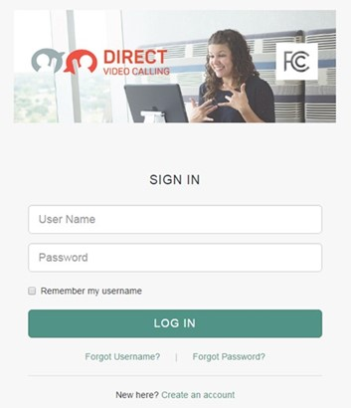

Figure 2. Screenshot of Agent Portal Login

Figure 3 presents a screenshot of the Agent Portal, which consists of the following elements:

* Side panels (left and upper right) to provide navigation and information to the Agent, including a videomail retrieval panel and an outbound calling dial pad
* A user chat area for RTT chats (right) with the VRS Consumer
* A header area that displays call duration information (top center) and a help button (upper right corner)
* Profile information displaying the Agent’s name and picture and the capability to sign out of the system
* VRS Consumer information such as first name, last name, etc.

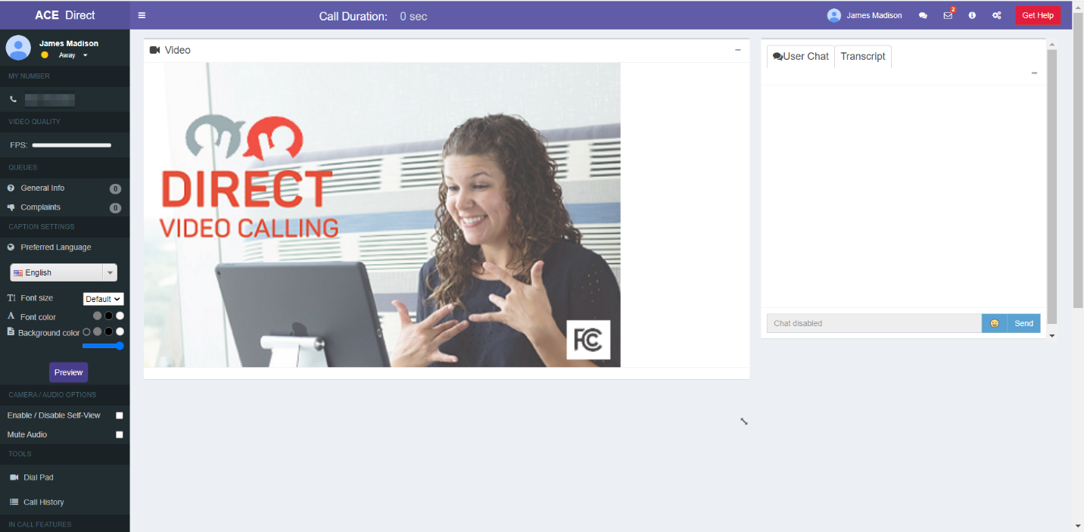

Figure 3. Screenshot of Agent Portal

When an Agent answers a call, the following in-call options are displayed as shown in Figure 4 which will allow the Agent to hover the mouse over icons to accomplish the following:

1. Enable/Disable Closed Captioning
2. Enable/Disable Microphone
3. Enable/Disable Video Stream
4. Record the Call
5. Enable/Disable Fullscreen
6. End the Call



Figure 4. Agent Portal Call Options When In-Call

### Left Navigation Panel

The ACE Direct Agent Portal desktop has a side panel that provides navigation and information to the Agent.

#### Main Navigation

As shown in Figure 5, the left side panel of the Agent Portal provides both Consumer Status and the Main Navigation. Here Agents can select their status as “Ready” or “Away” via the dropdown status change button. When an Agent first signs into the portal, the status defaults to “Away.” When the Agent is ready to receive calls, the Agent selects the “Ready” status. For an incoming call, an intermediate “Incoming Call” status appears, along with a modal alert dialog that takes the foreground. Once the Agent enters a call, the status changes to “In Call.” After the Agent leaves the call, the Agent is presented with a modal to enter either an “Away” or a “Ready” state. If the Agent chooses “Away,” the Agent can perform any tasks related to the call. Selecting the “Ready” state makes the Agent available to Consumers who have entered the call queue. If an Agent misses three consecutive inbound calls, the Agent’s status will automatically change from “Ready” to “Away” to avoid missing additional calls. NOTE: The default is three, however, this setting is configurable during installation.

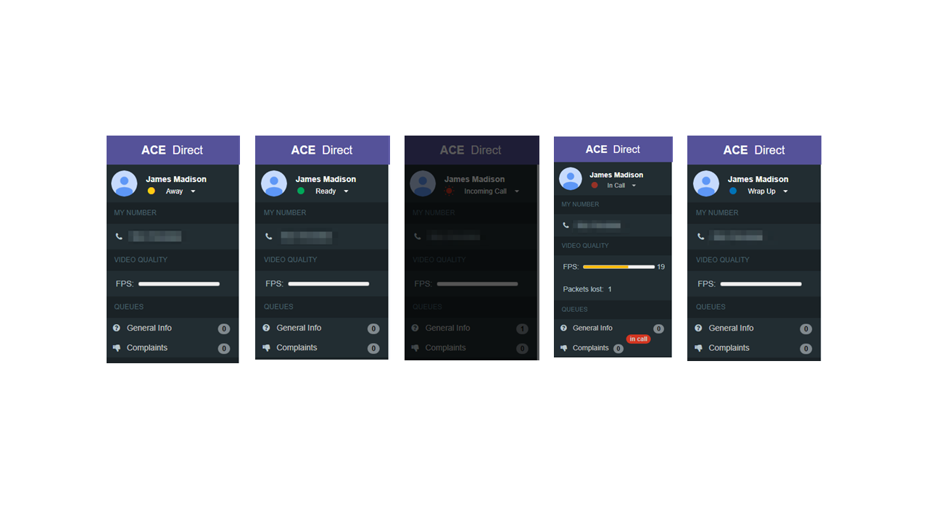

Figure 5. Screenshots of the Agent Statuses

Figure 5 also shows a frames per second (FPS) meter (highlighted by the red outline) that displays the frame rate at the agent portal while in a call. A dropped packet count will also be displayed under the FPS meter. This information can be used to determine the quality of the call.

As shown in Figure 6, a new Dial Pad feature at the middle of the left side panel allows Agents to place outbound calls. Clicking the Dial Pad icon expands the dial pad for outbound calling.

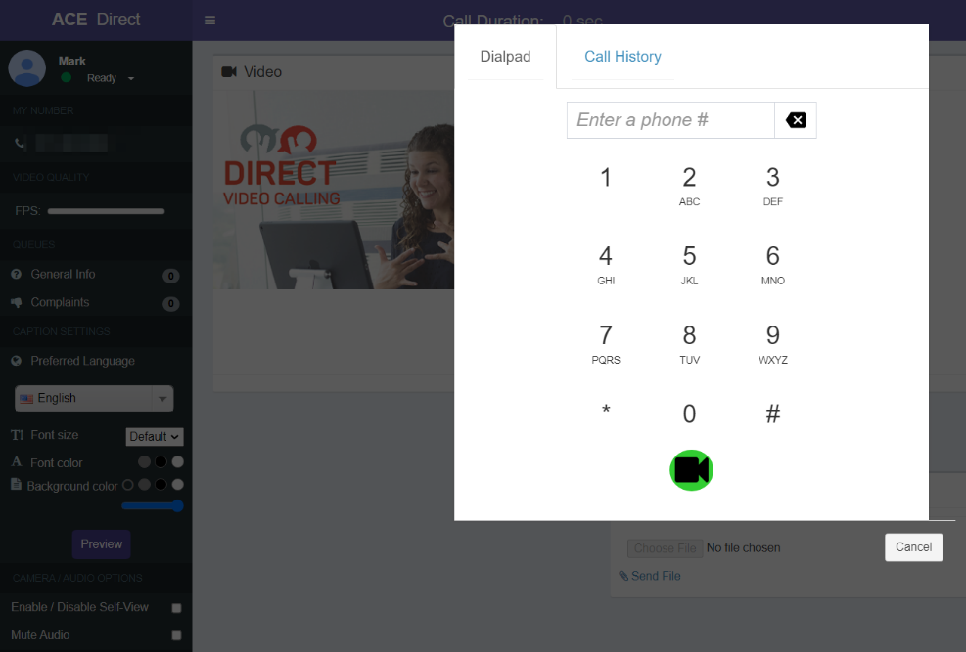

Figure 6. Dialpad for Outbound Calling

If the Agent does not input a valid 10-digit phone number, an error message will be displayed as shown in Figure 7.

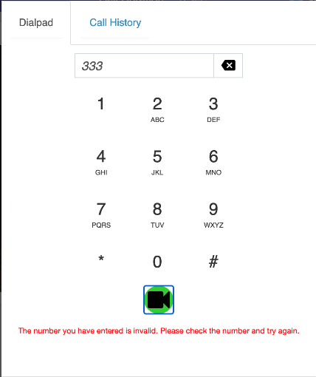

Figure 7. Dialpad Warning

Figure 8 is a dialog box to customize the display of the caption. It appears at the bottom left side panel. Caption font size, color, and background color can be modified at any time during a call. The Preferred Language must be established prior to receiving a call.

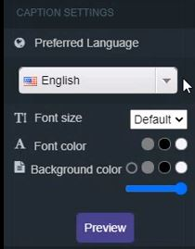

Figure 8. Caption Settings

As depicted in Figure 9, the In-Call options are displayed on the video pane and will allow the Agent to display Captions, Mute, Toggle Video, Record the Call, Minimize/Maximize the video portion of the screen and End the Call.



Figure 9. Screenshot of In-Call Options

#### Agent Preferred Language

An Agent may elect to converse in a language other than the system default of English. Prior to accepting a call, the Agent has the option to change the Preferred Language to something other than English by selecting the preferred language from the drop-down list, see Figure 10.



Figure 10. Agent Preferred Language

#### Call History

An Agent can view and scroll through a history of inbound and outbound calls received from both the Consumer Portal and provider videophones and softphones by clicking on Call History (Figure 11).

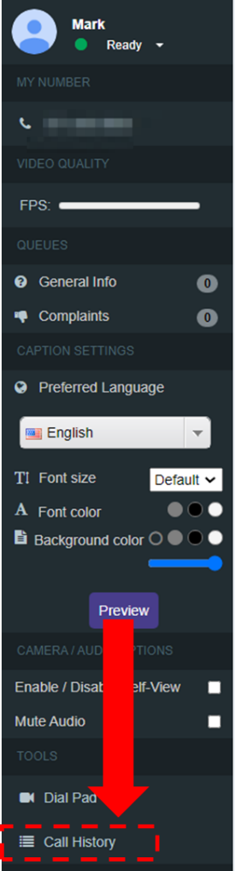

Figure 11. Call History

From the Call History list, an Agent can view details as well as select a number to call back. The list will provide a chronological listing of the calls and the respective call details, such as Name, Number, Duration, Date, and Time (Figure 12). The Agent can call a number from the Call History list by clicking the icon in the Callback column (right side of the screenshot).

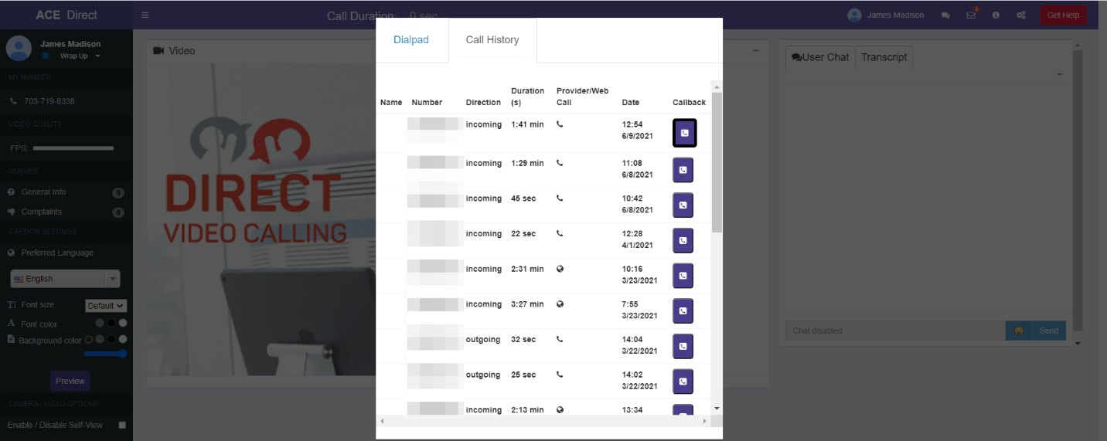

Figure 12. Call History Log

#### Agent Multi-Party Call

From the Agent Portal, Agents can add up to three Agents to a call by clicking on the Agents tab in the upper right corner, then selecting “Call”. The Agent will click on the “Dial Pad”, then dial the number of the additional party they wish to include on the call. The Agent can add two additional Agents to a Multi-Party call.

Figure 13 depicts three Agents and one Consumer in a simultaneous, Multi-Party Call. The Consumer will always be displayed in the upper left quadrant of the screen.

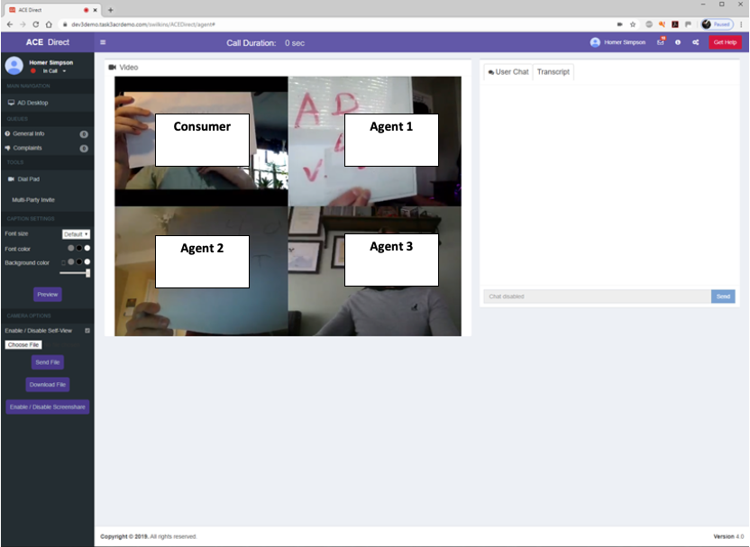

Figure 13. Screenshot of an Agent Multi-Party Call

#### Agent Screen Sharing

Using the Screen Sharing option, Agents can share their desktop screens with other ACE Direct callers during the call. To do that, the Agent clicks on the “Enable/Disable Screenshare” button on the Agent Portal on the left bar (as shown in Figure 14).

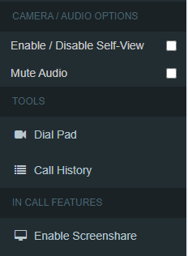

Figure 14. Agent Enable/Disable Screenshare Option

Figure 15 shows the “Share your screen” window with screen sharing options. The Agent can share the entire screen, an application window, or Chrome tabs.

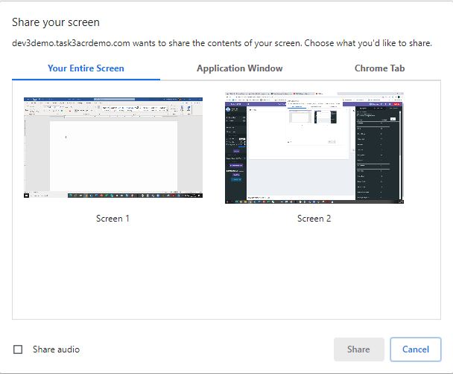

Figure 15. Agent Screen Sharing Options

Figure 16 depicts an Agent’s shared screen. To discontinue Screensharing, the Agent will click the “Enable/Disable Screenshare” button once again.

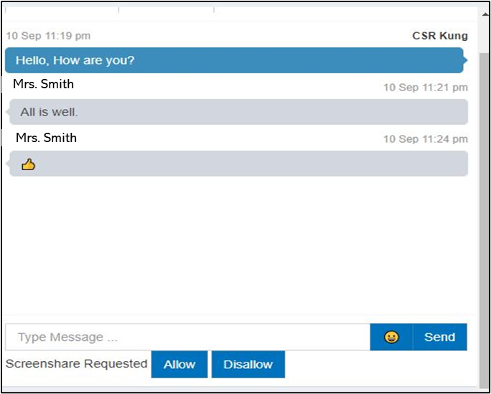

Figure 16. Screenshot of Agent Screen Sharing

#### Agent File Sharing

Files can be shared between two ACE Direct Agents and between an ACE Direct Agent and a Consumer who called in on the web portal.

#### Agent Sending Files

Files can be shared between ACE Direct Agents, e.g., Agent to Agent as well as Agent to Consumer. In the File Sharing window, the Agent will click on “Choose File.” Figure 17 shows that the Agent can select the desired file to send from the File Explorer window displayed.

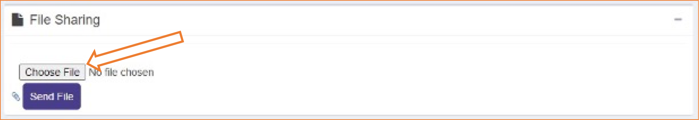

Figure 17. Agent Choosing a File to Share

After selecting the desired file, the Agent then clicks on the “Send File” button, as shown in Figure 18. Agents can share all types of files, including video (e.g., mp4). Each file must be sent individually. A virus scanner will scan each file before it is sent.

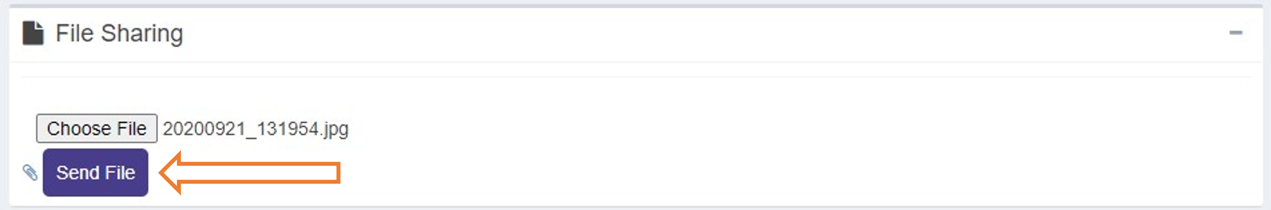

Figure 18. Screenshot of Agent Sending Files

The selected file will be displayed to the right of the Choose File button. Once the file has been sent successfully, the Agent will receive a confirmation message (Figure 19).

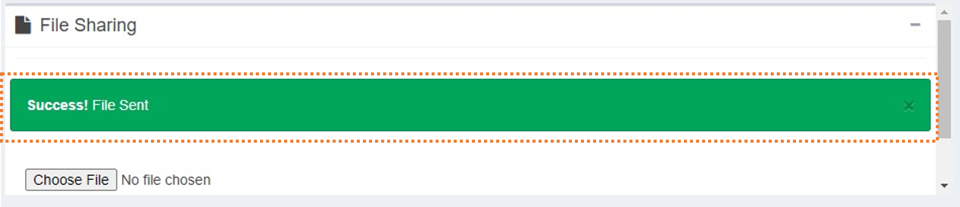

Figure 19. Agent Sent File Confirmation

If the virus scanner flagged the file or if there is another error, the Agent will receive an error message (Figure 20).

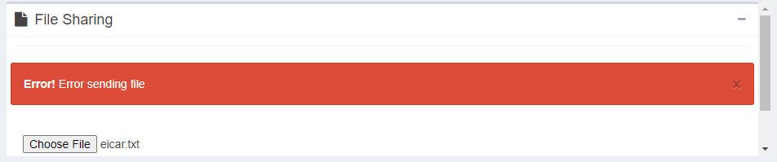

Figure 20. Agent Sent File Error

#### Agent Downloading Files

Agents can download files they receive from other Agents or from Consumers by clicking the button containing the filename in the File Sharing window on the Agent Portal as shown in Figure 21.

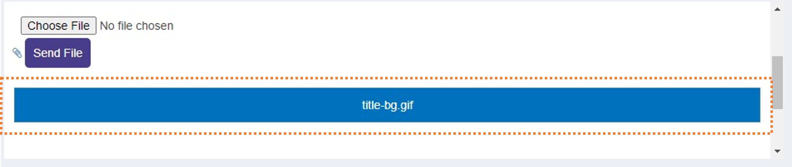

Figure 21. Screenshot of Agent Selecting Download File Option

Agents can download all types of files, including video (e.g., mp4). Each file must be downloaded individually, and each file cannot be larger than 15MB in size.

#### Right Side Panel (Agent Status and Videomail Mailbox)

The right-side panel as shown in Figure 22 is accessible by clicking on the gear icon in the top right corner of the portal. The Agent can reach the videomail mailbox directly by clicking on the envelope icon in the top right corner of the portal.

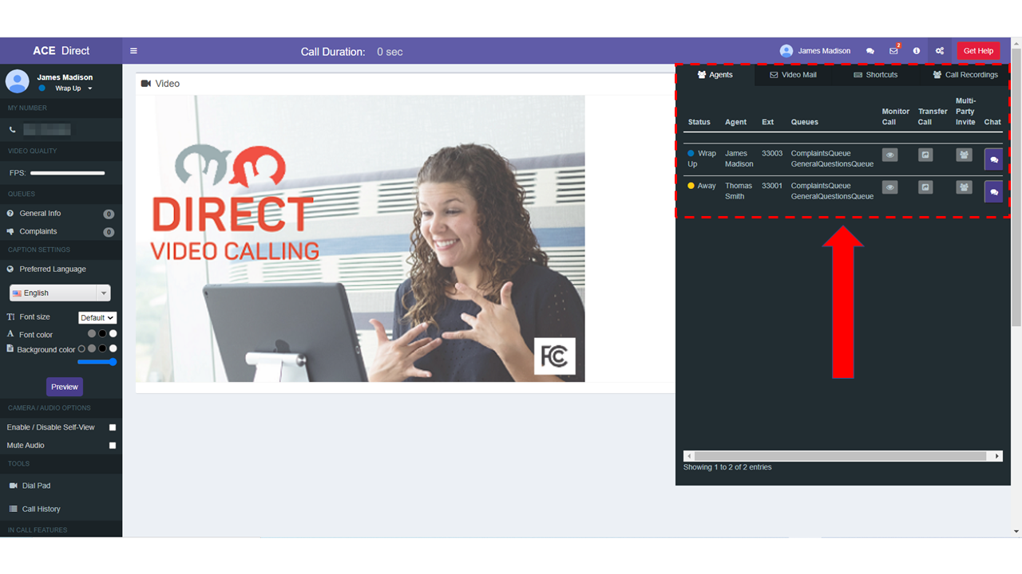

Figure 22. Screenshot of Agent Right Panel

This section can be collapsed to give the Agent more space for the main content area. By opening the right-side panel, the Agent can access four tabbed content areas (Agents, Video Mail, Shortcuts and Call Recordings) as depicted in Figure 23.

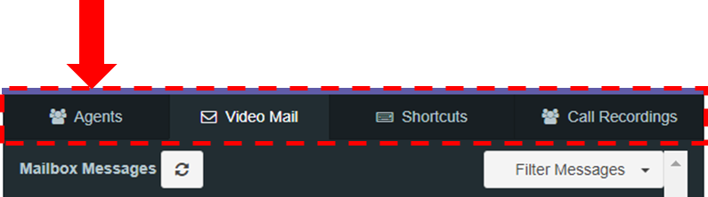

Figure 23. Screenshot of Agent Status

##### Agent Status

The Agent Status section provides the Agent with a list of Agents logged into ACE Direct. The Agent can view information about each Agent listed, such as their status, extension, and queues, as highlighted in Figure 24.

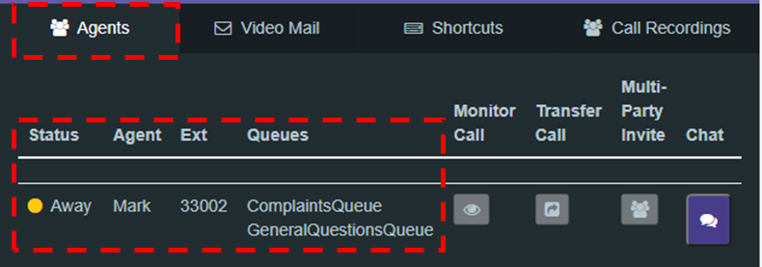

Figure 24. Agent Status Information

##### Videomail

The Videomail tab, as shown in Figure 25, displays a list of videomails received while the Agents were unavailable to take calls. This list provides the Agent with the videophone number, time, date, duration, and status of the videomail. The Agent can sort the videomail table by any of the columns in ascending or descending order and can filter the videomail by status. The status may be “Unread,” “Read,” “In Progress,” or “Closed.” Unread videomails are highlighted in **boldface**. An indicator at the top right of the screen provides the Agent with a count of unread videomails. Because videomails are not specific to an Agent, all Agents are presented with the same list of videomails.

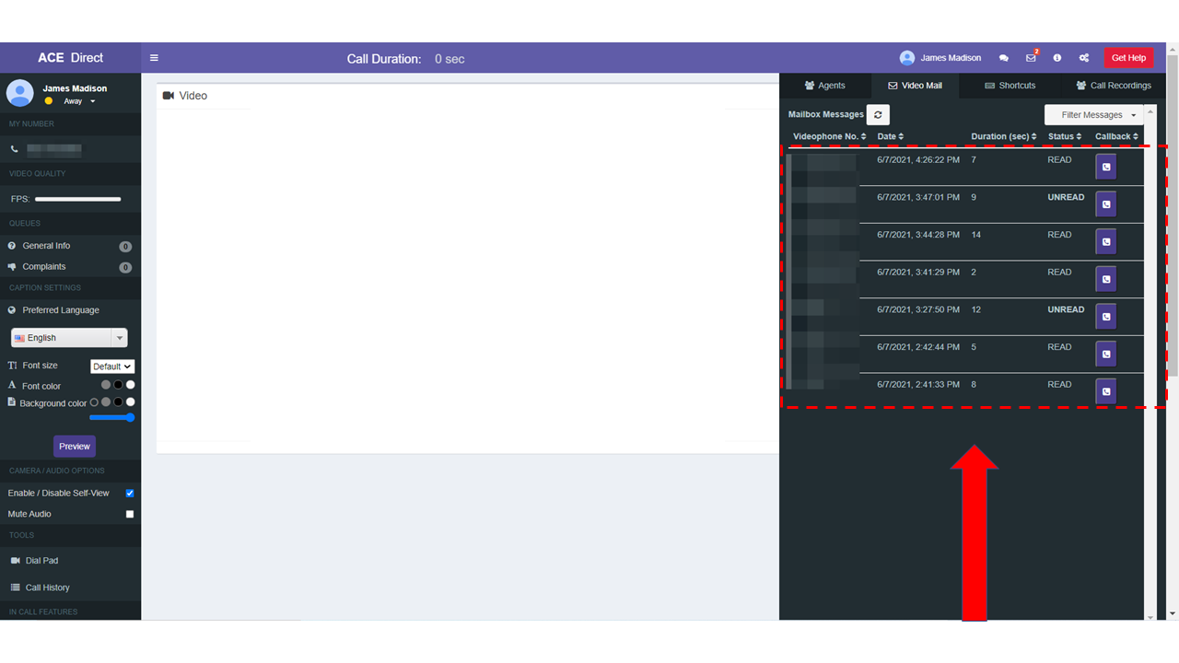

Figure 25. Screenshot of Agent Videomail Mailbox

By clicking on a specific videomail, the Agent can view the contents and update the status of the videomail. Figure 26 displays the playback screen.

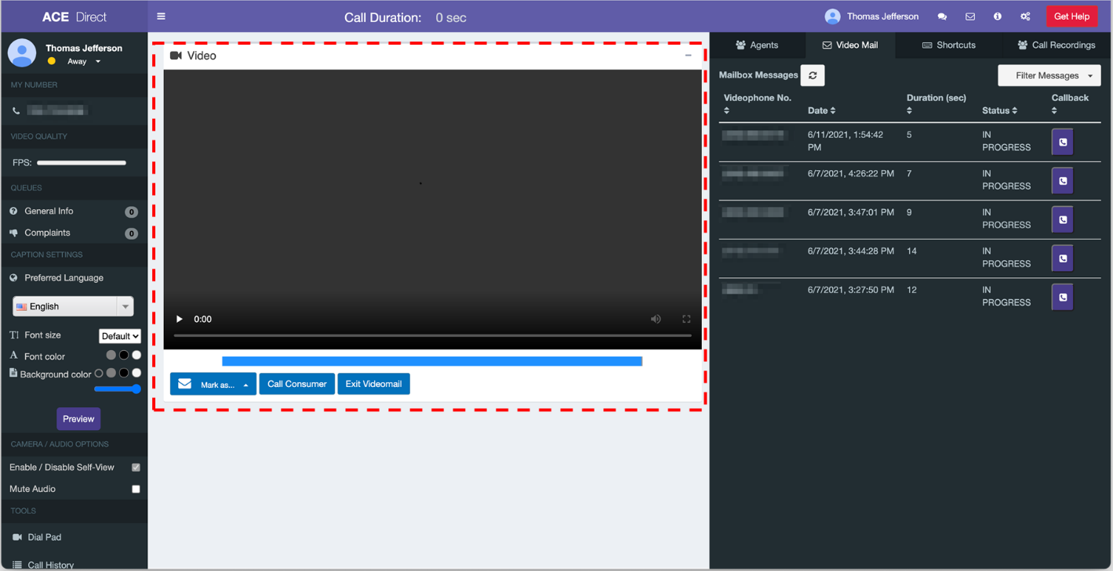

Figure 26. Screenshot of Videomail Playback

The videomail status can be changed to “Unread,” “Read,” “In Progress,” “Closed,” or “Deleted” as shown in Figure 27. If the Agent deletes the videomail, it is removed from the videomail mailbox.

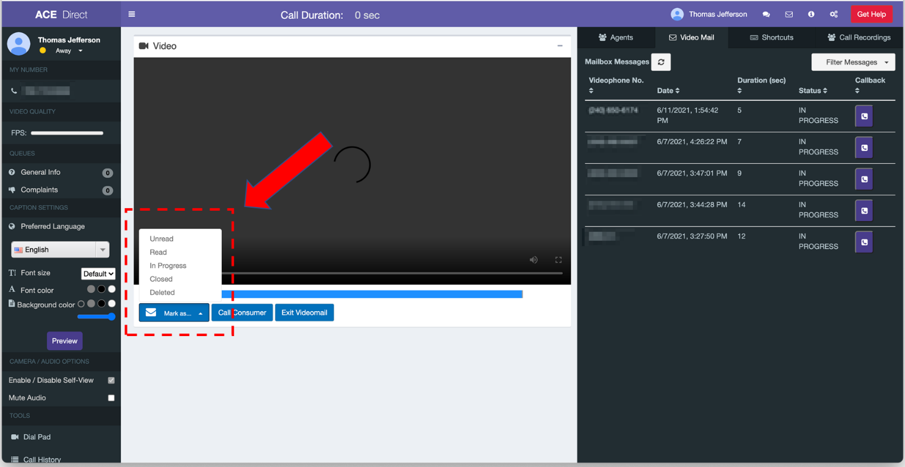

Figure 27. Screenshot of Videomail Options

The Agent can also place a call to the videophone number associated with the videomail by clicking on the icon under the Callback column as shown in Figure 28).

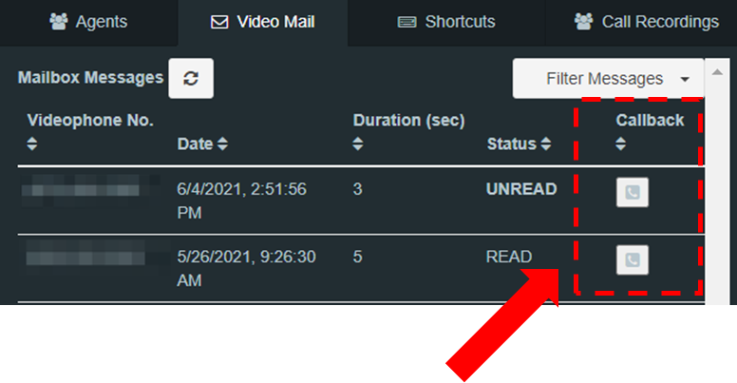

Figure 28. Screenshot of Callback Option in Videomail Mailbox

##### Agent to Agent and Broadcast Messaging

Agents can send messages to each other via the Agent-to-Agent Messaging feature. This is available before, during, and after a call. To do so, an Agent will click on the Chat icon that corresponds to the Agent they wish to message as depicted in Figure 29.

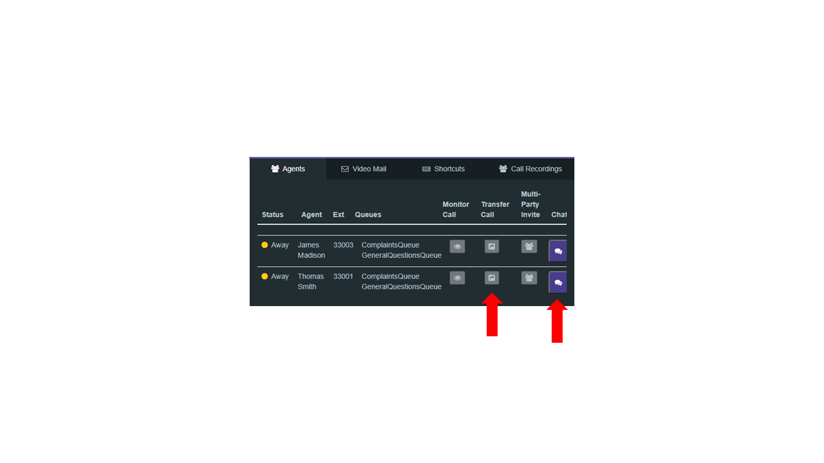

Figure 29. Agent to Agent Chat Option

In Figure 30 below, Agent Lao, wants to have a text conversation with Agent Annie. A chat window will be displayed for Agent Lao to enter their message, see 1. After entering the message, the Agent Lao clicks the Send button to begin the text conversation with Agent Annie.

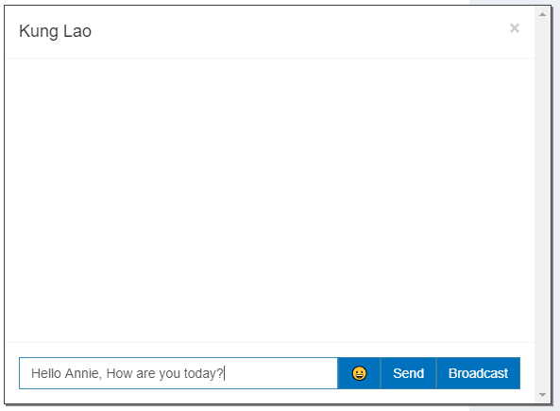

Figure 30. Agent to Agent Chat Message Window

After clicking “Send”, Agent Annie receives Agent Lao’s message as depicted in Figure 31. Agent to Agent chat messaging is a two-way conversation between two Agents only, thus only the two Agents involved can respond.

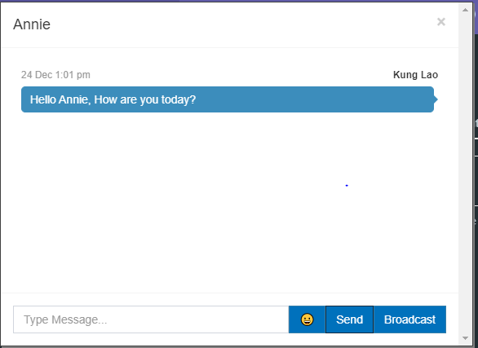

Figure 31. Agent to Agent Chat Message Received

If an Agent would like to send a single message to several Agents simultaneously, the Agent will type their message, click the “Broadcast” button, then click “Confirm”, see Figure 32.

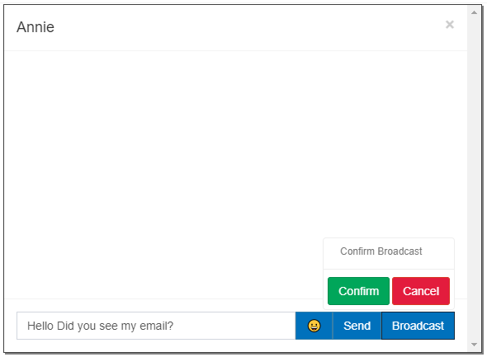

Figure 32. Agent Sending Broadcast Message

The message will be broadcasted to all Agents that are online at the time the message was sent. Agents that are offline will not receive the broadcasted message. A confirmation of the broadcast will be displayed after clicking “Confirm”, see Figure 33.

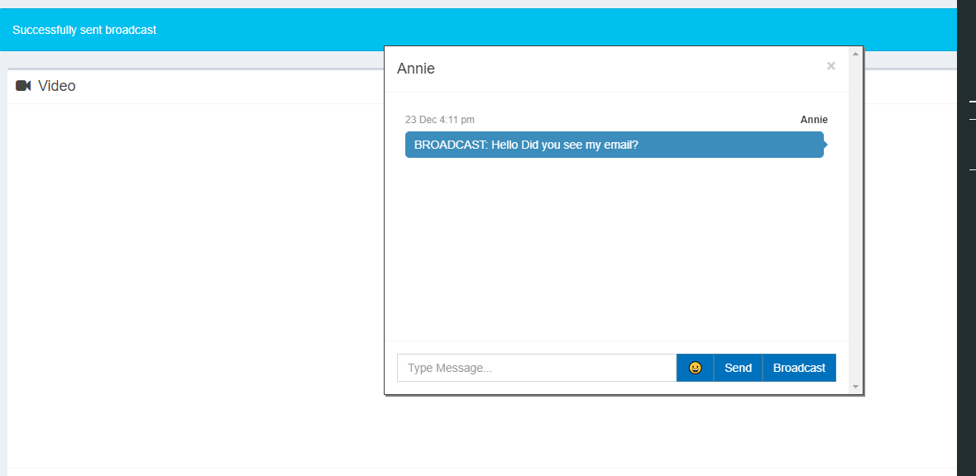

Figure 33. Agent Broadcast Confirmation Message

In the Chat window, the Agent will be able to denote which messages were broadcast because the title “BROADCAST” appears in front of the message, see Figure 34.

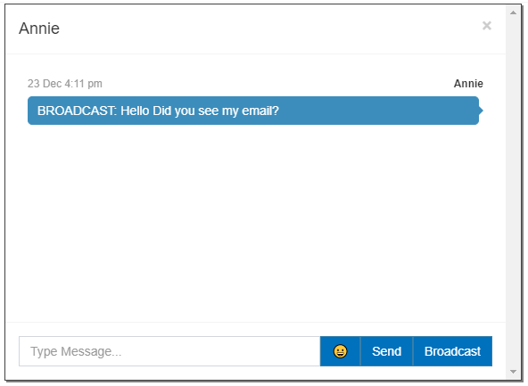

Figure 34. Agent Broadcast Message Received

##### Agent Portal Shortcuts

Agents can use keyboard shortcuts to navigate the Agent Portal. The Agent can click on “Shortcuts” to reveal a list of default shortcuts.

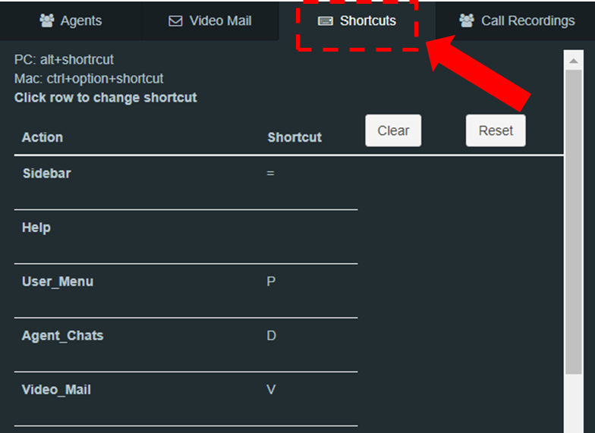

Figure 35. Agent Portal Shortcuts Menu

The Agent can customize shortcuts by selecting “Clear” and then clicking on the row to enter a new key sequence for their unique shortcut as depicted in Figure 37. The Agent can reset the shortcuts to their default by clicking “Reset.”

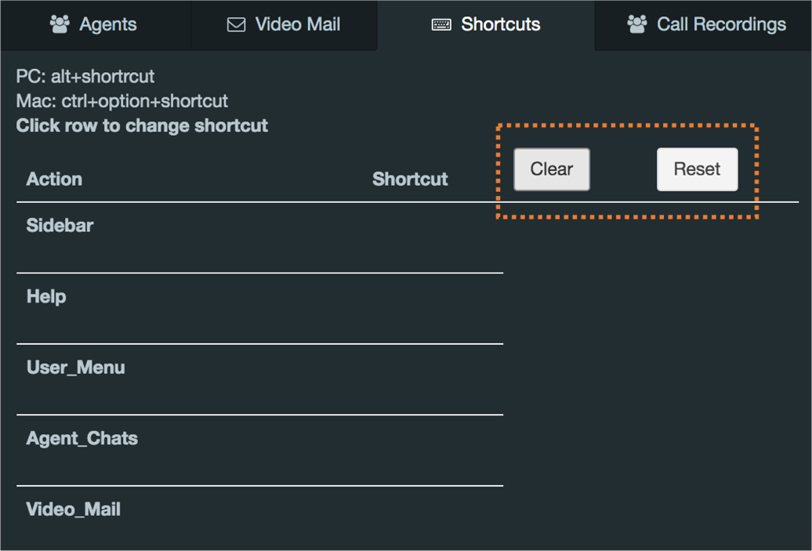

Figure 36. Agent Shortcuts Cleared

##### Agent Call Recording

Agents in a call may now record the *current* call. To initiate a call recording while in a call, an Agent will see a red dot icon among the Agent call buttons as shown in Figure 38*.*



Figure 37. Call Recording Button

By clicking this button while in a call, the button will turn green notifying the Agent that the call is being recorded. Figure 38 shows the immediate result for the Agent.

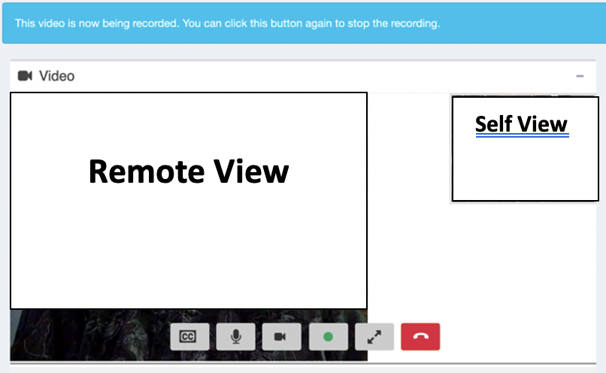

Figure 38. Call Recording Activated View

By clicking the green record button again, an agent can then stop the recording. This will then cause the recording and its information to be saved. While outside of a call, an Agent can view a recording by clicking the gears icon in the upper right corner of the page, selecting the call recording tab, and then clicking on the specific recording the Agent would like to view. We can see this specific action in Figure 39.

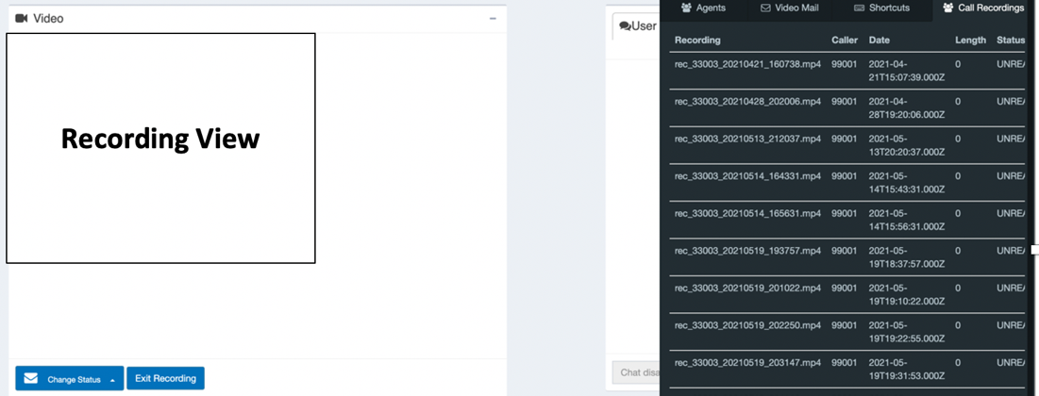

Figure 39. Call Recording Playing

While in this mode the Agent can select from a dropdown to change the status or delete a call recording. The agent may also click the Exit Recording button.

*2.6.2.6.6*  *Call Transfers*

Agents in a one-to-one call can transfer the consumer to another available Agent. To do so, the Agent will click on the Transfer Call icon as depicted in Figure 40 for the destination Agent.

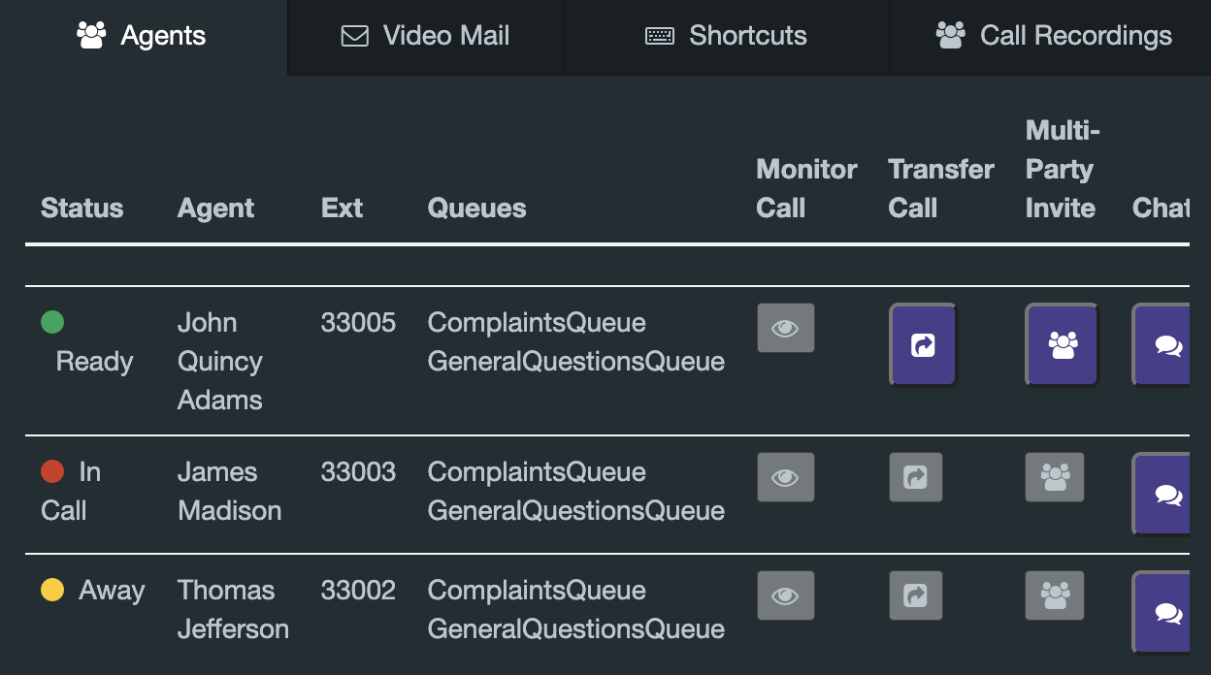

Figure 40. Call Transfer Option

When the Agent in call clicks the Transfer Call icon, a popup shown in Figure 41 will appear, prompting the Agent to choose a transfer type. ACE Direct supports Cold and Warm Transfers.

A Cold Transfer rings the destination Agent and transfers the call if the destination Agent answers the call. A Warm Transfer creates a multiparty call with the two Agents and the Consumer – this gives the original Agent the opportunity to introduce the Consumer to the second Agent. In both cases (Cold Transfer and Warm Transfer), the call returns to the original Agent if the called Agent does not answer.

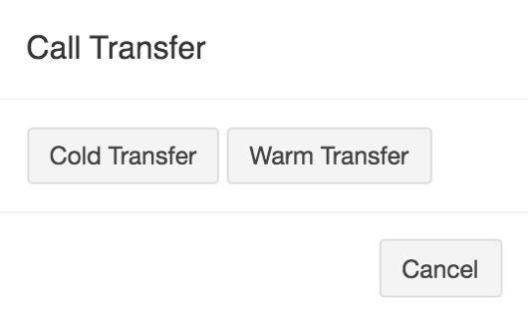

Figure 41. Call Transfer Types

Once the Agent chooses a transfer type, the Agent receiving the call transfer will receive a modified ringing popup as shown in Figure 42.

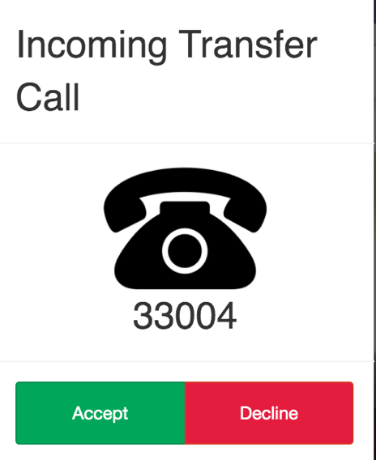

Figure 42. Transfer Call Ringing Popup

When the Agent receiving the call transfer clicks Accept, the consumer will be transferred. If the transfer was a Cold Transfer, the original Agent will automatically leave the call. A modified Wrap Up notification shown in Figure 43 will appear to confirm the transfer was successful. If the transfer was a Warm Transfer, the original Agent and the Agent receiving the call transfer will be placed in a multiparty call with the consumer.

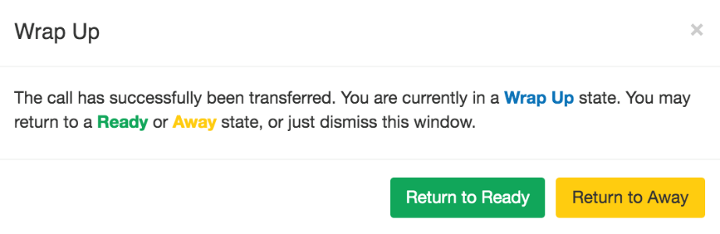

Figure 43 Wrap Up Notification After Transferring a Call

*2.6.2.6.7* *Call Monitoring*

Agents can view an ongoing call being serviced by one of the Agents active on ACE Direct. As shown in Figure 44, an Agent will have a Monitor Call column visible in the Active Agents list. The Monitor Call icon will only be enabled when the status of the corresponding Agent is “In Call.”

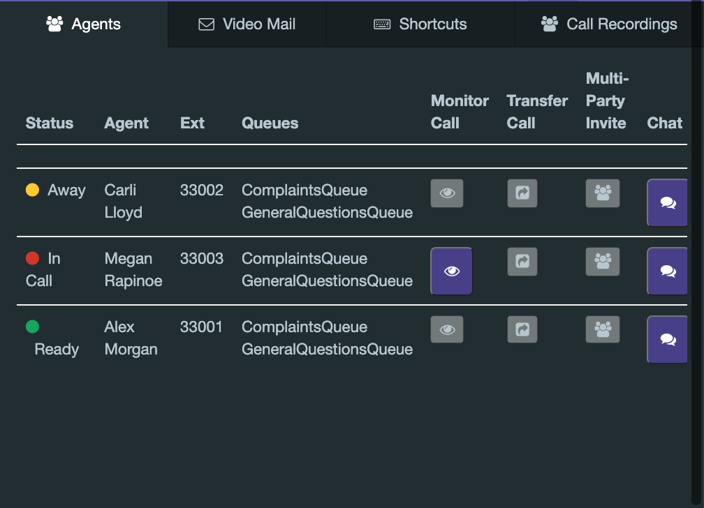

Figure 44. Call Monitoring Option

The Agent can click on the Monitor Call button shown above to join the ongoing call as an observer. Once the Agent joins the call as a Monitor, both the Agent and Consumer video will be displayed on the Monitoring Agent’s screen. Neither the Agent nor Consumer will have any indication that the call is being monitored. As shown in Figure 45, the Monitoring Agent’s in-call options are displayed on the video pane. These allow the Monitor to Disable/Enable Captions, Maximize/Minimize the video, and Stop Monitoring the Call.



Figure 45. In-Call Options While Monitoring

The Monitoring Agent will be able to download files sent by the Consumer, see all in-call messages being sent between the Agent and Consumer, and see the captions of both the Agent and Consumer. The Monitoring Agent cannot participate in the call in any way. File Share, Screen Share, and In-Call Chat options are disabled for the Monitoring Agent. The Monitoring Agent can stop monitoring the call at any time by clicking the Stop Monitoring option (red hang-up button) shown in Figure 45. Both the Agent and Consumer being monitored can hang up the call at any point.

### Video and Real-Time Text Communications

The ACE Direct platform supports the following methods of communication: voice, video, RTT, and captioning. This subsection focuses on video and RTT.

#### Agent Video Chat

Video Chat communications on the platform occur through the browser using WebRTC technology. If the Consumer is using a computer or smartphone, the Consumer must use a WebRTC-compatible browser (e.g., Google Chrome) to enable this functionality. Video Chat can also be used with a VRS provider videophone. During a call, the Agent has button options to mute audio, mute video, or view the Consumer’s video in full screen mode. Figure 46 shows the video of the Consumer in full screen mode while the Agent’s self-view video remains in the upper right corner.



Figure 46. Screenshot of Full Screen Video Mode

#### Agent Portal Captioning

ACE Direct generates captions of user conversations and displays the text under the video screen so that it does not interfere with the video. The caption text displayed on the Agent Portal shows captions corresponding to the words spoken by the Consumer. Caption text attributes such as size, text color, and background color can be dynamically changed using the caption settings/controls. Figure 47 shows a screenshot sample of captioning in the Agent Portal.

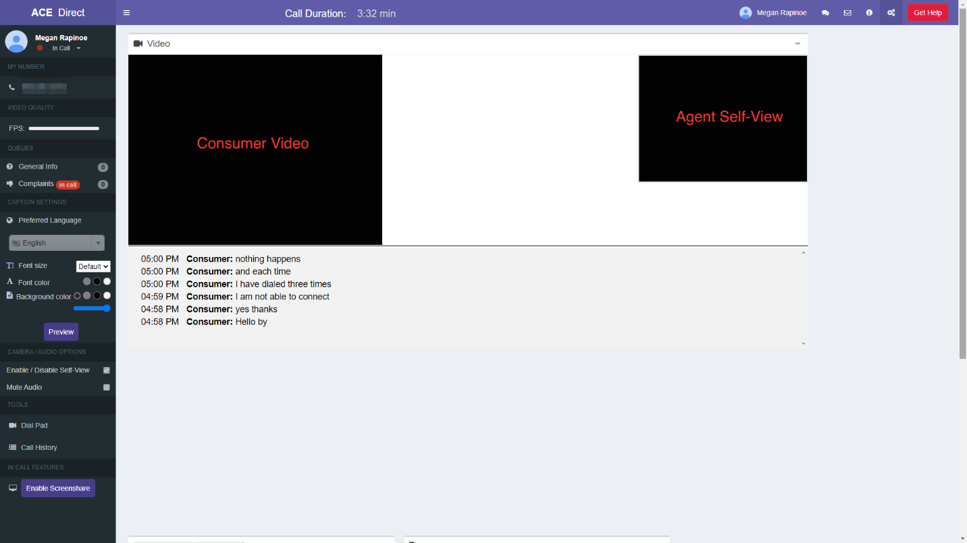

Figure 47. Screenshot of Sample Captioning on the Agent Portal

#### Real-Time Text Chat

The User Chat window, as shown in Figure 48, provides the Agent another channel of communication with the Consumer. As the Agent types a message to the Consumer in the input field, the Consumer will view the message in real time. The chat history remains visible to the Agent until the Agent closes the ticket. Use of the real-time text chat feature is not available for videophones as of this publication. The Agent and Consumer can select from a list of emojis to add emphasis in their text messages.

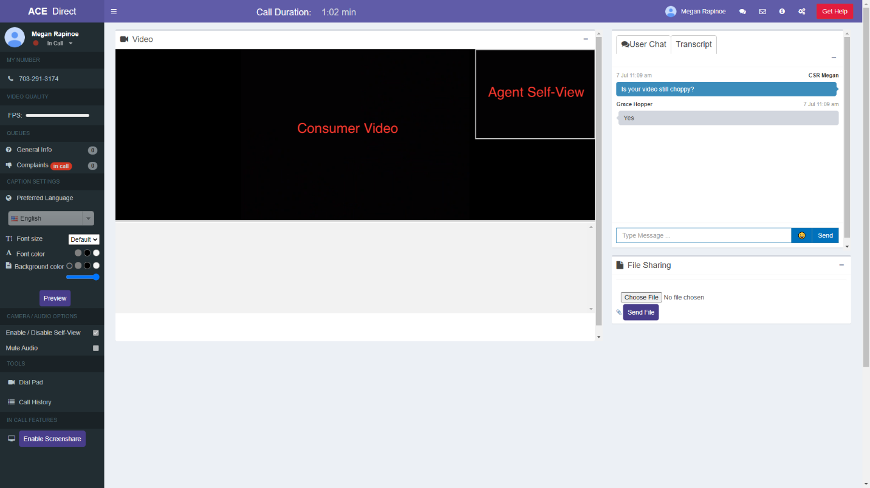

Figure 48. Screenshot of User Chat Window

### Agent Portal Header

The Agent Portal header provides the Agent with the following items: call duration information, help button, profile information about the Agent, and the capability to sign out of the system.

#### Call Duration and Get Help Button

The Call Duration, located in center section of the top header, shows a running clock of the call length once the Agent accepts the incoming Consumer call. As shown in Figure 49, the “Get Help” button allows the Agent to request help from the Manager during a call. When the Agent clicks the “Get Help” button, the Agent’s name will change color and begin to flash on the Management Dashboard to indicate the Agent needs help.

Figure 33 presents a screenshot showing call duration and the assistance button (highlighted by a dashed border box as described in the text immediately preceding the figure.

Figure 49. Screenshot of Call Duration and Assistance Button

#### Agent Profile

After logging in, the Agent’s name and picture will appear in the Agent Profile at the top right corner of the Agent Portal head as shown in Figure 50. (As a default, all Agents display the same profile picture.) The Agent has the capability to log out of the ACE Direct Portal by clicking the “Sign out” button. If the Agent has changed the layout of the Agent Portal, it can be reverted to the original layout by clicking the “Default Layout” button.

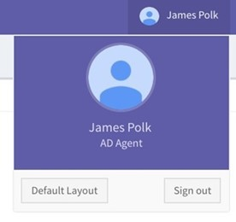

Figure 50. Screenshot of Agent Profile

### Video Relay Service

#### Video Relay Service Information

The VRS Information section displays information about the Consumer currently on file in the CRM system. Figure 51 shows that after the call has ended, the Agent must click on the “Save” button in the VRS Information box to return to the queue and receive new calls.

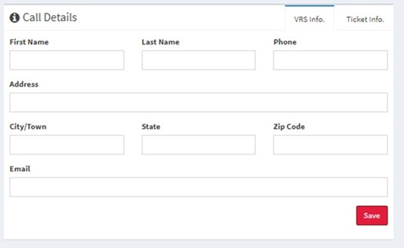

Figure 51. Screenshot of VRS Information

## Kuando Busylight Visual Ring Indicator and Agent Status

ACE Direct incorporates the Kuando Busylight device as an integral part for notifying call center personnel of incoming calls and the status of an Agent (such as “Away,” “Ready,” “In Call,” etc.). The Administrator can configure the color of the light and ensure a consistent configuration across all Agents. Subsection 2.7.2 presents an example configuration.

The Kuando Busylight is not included with the ACE Direct platform and must be purchased separately. The Kuando Busylight is available in several different models and from several online vendors.

### Agent Status

Each Agent has a status based on the Agent’s activity with ACE Direct, as shown in Table 5.

Table 5. Agent Status

| Agent Status | Definition |
| --- | --- |
| Away | The Agent is not available, and no calls will be directed to them. |
| Ready | The Agent is available to take calls from the queues. |
| In a Call | The Agent is currently handling a call. |
| Incoming Call | The Agent is receiving a call but has not yet answered it. |
| Wrap Up | The Agent just finished a call but has not yet hit “Return to Ready” or “Return to Away”. No calls can be directed to the Agent. |

The Agent Status, presented by coordinated color and lighting pattern, is communicated via the Kuando Busylight device and displayed in the Agent Portal as described in subsection 2.7.2. Figure 53 shows the definitions correlated with the different colors available. The configurations can be reset to the default values at any time by clicking “Reset to Default” in Figure 53.

### Kuando Busylight Light Configuration

Managers can customize the color associated with each possible Agent status through the Light Configuration page in the Management Portal as shown in Figure 52. Soon after a Manager saves the form, the color is updated in real time and appears on the Agent’s Kuando Busylight as well as in the Agent Portal, as shown in Figure 52 and Figure 53.

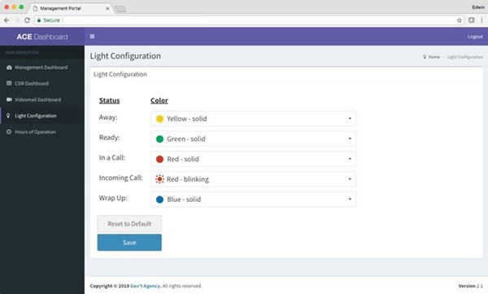

Figure 52. Screenshot of Kuando Busylight Light Configuration Page

Figure 53 shows the default color scheme. Using the “Reset to Default” button, the status and color selections will revert to the default settings.

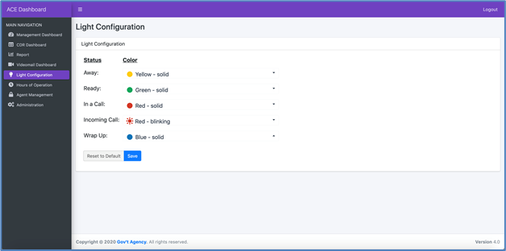

Figure 53. Screenshot of Kuando Busylight Default Color Scheme

### Lightserver

Lightserver is a standalone Electron application that must execute on the Agent’s desktop computer. (A Kuando Busylight device must be connected to a USB port on the same computer before starting the Electron application.) The Lightserver program is a graphical user interface (GUI) for integrating the Kuando Busylight with the ACE Direct platform. It provides a RESTful interface via localhost only to the Agent Portal. When the Agent status changes, the Agent Portal makes RESTful calls to the Lightserver program.

ACE Direct makes the initial connection to Lightserver when the Agent navigates to the ACE Direct Agent Portal. This connection enables all requests from the ACE Direct Agent Portal to Lightserver, as shown in Figure 54.

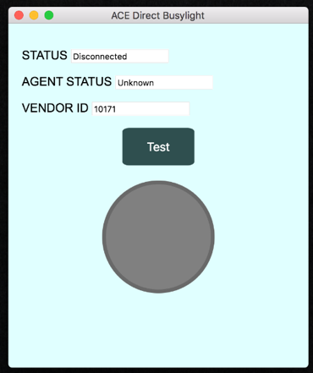

Figure 54. Lightserver GUI

At startup, the Lightserver GUI attempts to detect a connected Busylight device, perform a self-test, and start its server. At this point, an ACE Direct Agent may connect to the Kuando Busylight device from the ACE Direct Agent Portal. The Lightserver GUI has the data elements shown in Table 6.

Table 6. Lightserver GUI Data Elements

| Data Element | Description |
| --- | --- |
| Status | The current state of the Lightserver program (e.g., Running, Stopped, …) |
| Agent Status | The status of the connected Agent (e.g., ready, away, in call, …) |
| Vendor | The vendor of the light device; currently only PLENOM is supported |
| Test | Perform a self-test of the connected Busylight device |

## Consumer Help Center

The design of the Consumer Help Center, also known as the Consumer Portal, gives Consumers the option to submit information before initiating a call with an Agent. The Consumer uses a web form to submit information to document the complaint.

The following two steps are required to access the Consumer Help Center:

1. Start the browser on a machine that can access the Consumer Help Center.
2. Enter a URL like https://<hostname>/ACEDirect/Complaint, where <hostname> is the host name of the ACE Direct server. The exact URL depends on your installation and customization of ACE Direct.

### Submit a Complaint

The descriptions and web forms presented in this subsection demonstrate how to submit Consumer complaints in the ACE Direct system.

#### Verify Videophone Number

Figure 55 shows the opening page of the Consumer Portal (Consumer Help Center). Consumers enter their videophone numbers here. The ACE Direct system validates the videophone number before allowing the Consumer to proceed.

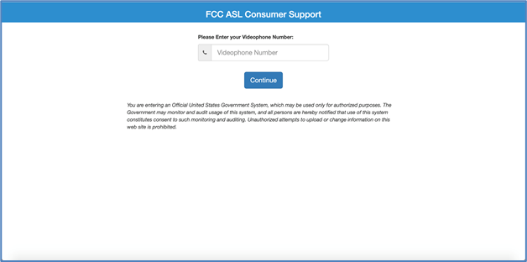

Figure 55. Screenshot of Consumer Help Center

If the Consumer enters an incorrect videophone number, an error message is displayed, see Figure 56.

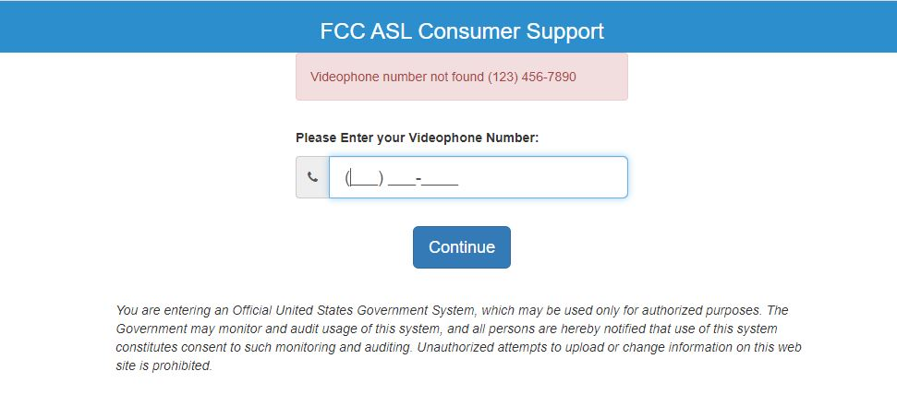

Figure 56. Consumer Incorrect Number Message

#### Select Chat/Caption Language

After verifying the videophone number through the iTRS-ENUM database, the portal displays the Consumer Complaint page with a popup menu for the consumer to select their preferred language for chat and captioning as shown in Figure 57.

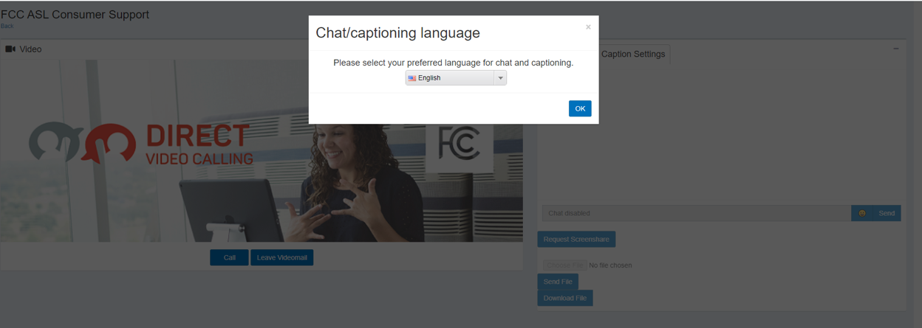

Figure 57. Consumer Portal Language Option

There are several languages the consumer can choose from. See the list in Figure 58.

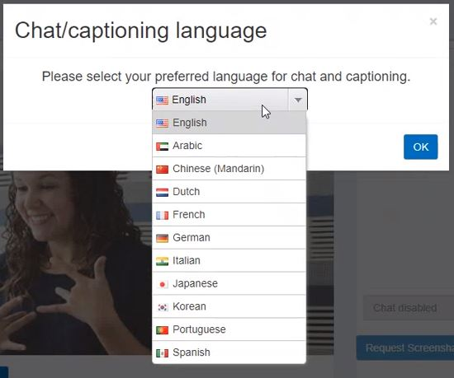

Figure 58. Consumer Portal Language List

For example, if the consumer selects Spanish and then clicks OK, the following consumer portal displays. See Figure 59.

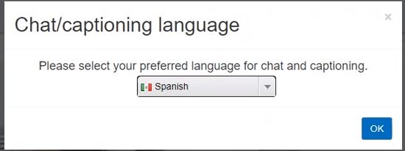

Figure 59 Consumer Portal Language Set to Spanish

The Consumer Portal will indicate the preferred language is Spanish. See Figure 60.

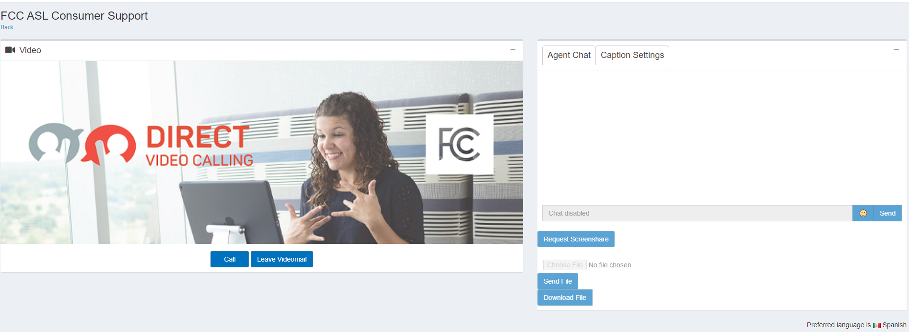

Figure 60 Consumer Portal Language Changed

The default preferred language is English.

#### Complete the Consumer Complaint Form

After verifying the videophone number through the iTRS-ENUM database, the portal displays the Consumer Complaint as shown in Figure 61. If the Consumer had a prior ticket in the CRM system, the videophone number information provided on the previous form is displayed in the VRS Information section via a ticket lookup as shown in Figure 61. These fields will be empty if this is the Consumer’s first call.

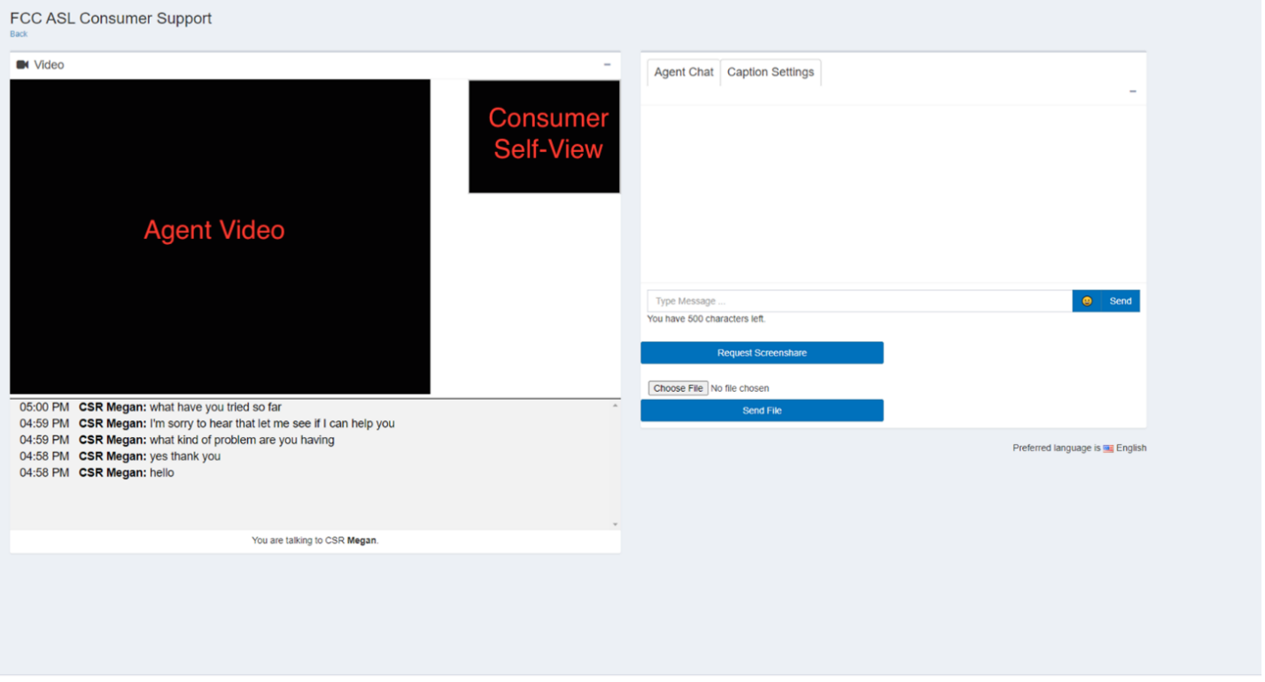

Figure 61. Screenshot of Consumer Complaint Form

#### Consumer Video Chat

After submitting the complaint ticket and receiving a ticket number, the Consumer presses the “Call” button and is connected to an available Agent. Video is the primary form of communication. As shown in Figure 62, the Agent’s video is displayed in the video box in the center of the screen.

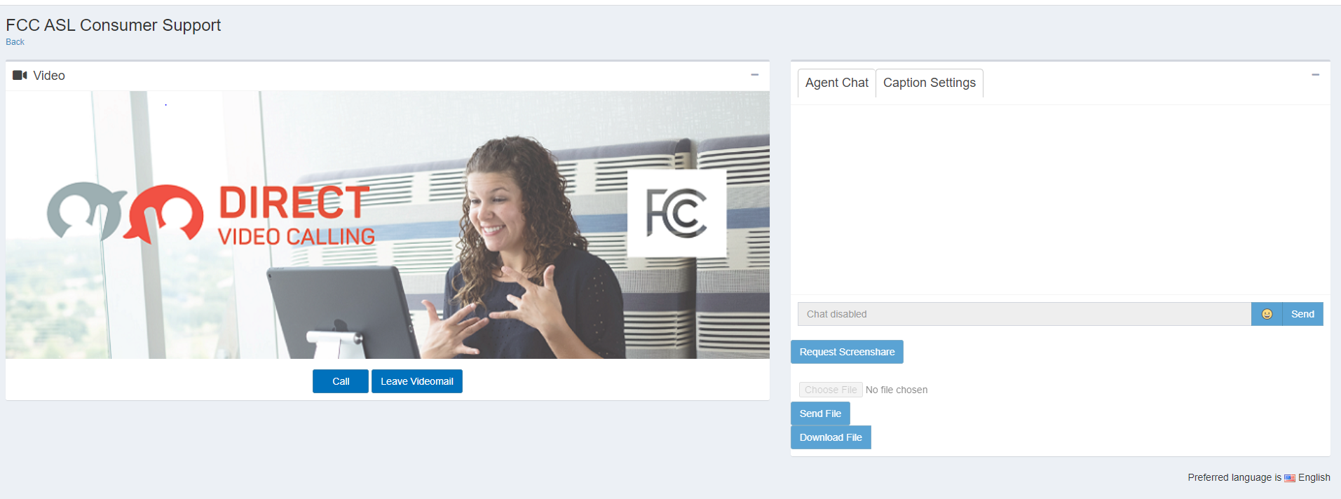

Figure 62. Consumer Video Chat Window

During a call, the Consumer has options to display captions, mute audio, mute video, or view the Agent’s video in full screen mode (Figure 63).



Figure 63. Screenshot of Consumer Video Chat In-Call Options

#### Consumer Portal Captioning

ACE Direct generates captions of user conversations and displays the caption text under the Agent video. The text displayed on the Consumer Portal shows captions corresponding to the words spoken by the Agent. Caption text attributes such as size, text color, and background color can be dynamically changed using the caption settings/controls. Figure 64 shows sample captions on the Consumer Portal in the Caption Settings on the right side of the panel.

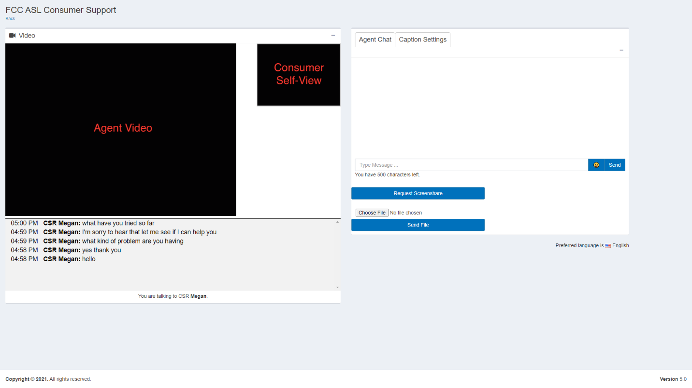

Figure 64. Screenshot of Sample Captions on the Consumer Portal

### Use Real-Time Text Chat

The Agent Chat pane on the right side of the screen provides the Consumer with another channel of communication with the Agent. Notifications appear while the Consumer types a message to the Agent and vice versa. The messages will show up in real time, and the chat history will remain visible until the Agent closes the ticket. As shown in Figure 65, ACE Direct allows a maximum of 500 characters per line during the Agent chat.

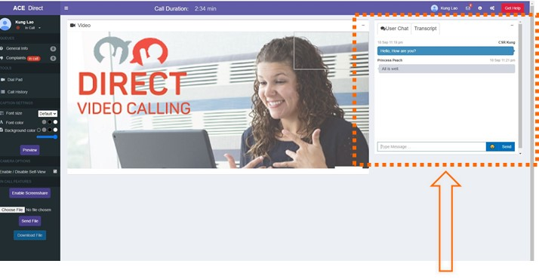

Figure 65. Agent Real-Time Chat Window

When an Agent becomes available, the video chat will begin. Caption transcripts from the Agent appear in the Transcript tab. After the Consumer or the Agent hangs up, the Consumer is redirected to a page defined during implementation. At the end of the call, ACE Direct can redirect the user to a specific website by updating the redirect setting in the configuration file.

### Leave a Videomail

A Consumer may leave a videomail by pressing the “Record” button on the screen as shown in Figure 66. This flow is for illustrative purposes and should be customized to fit the needs of the Consumers.

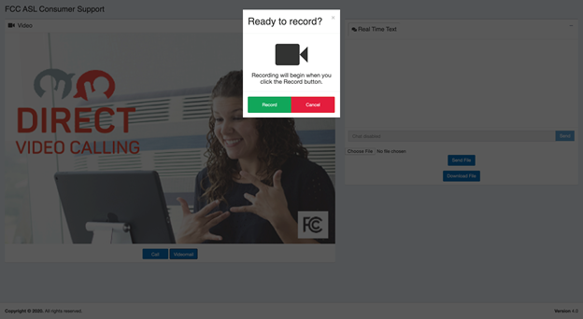

Figure 66. Screenshot of Ready to Record

Consumers see a self-view during recording. The default maximum length for a recording is 90 seconds and a status bar shows the remaining time for the recording. The maximum videomail length is a configurable parameter. Figure 67 shows the Consumer Portal with a videomail recording in progress. During operation, the video would show the Consumer Self-View.

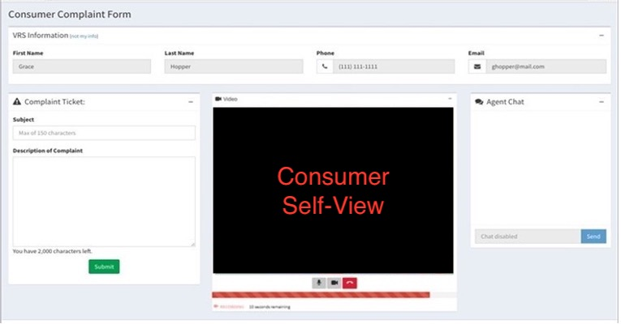

Figure 67. Screenshot of Videomail Recording in Progress

### Consumer Multi-Party Calls

Consumers can participate in calls with multiple parties connected in the same call. An ACE Direct Agent must initiate all multi-party calls. For more information, please refer to Subsection 2.6.2.4

### Consumer Screen Sharing

Consumers can use the Screen Sharing option to share their screens with other ACE Agents during the call, as depicted in Figure 68. The Consumer sends a request to the Agent to initiate the Screen Share function. If the Agent accepts the request, the Screen Share option will initiate on the Consumer’s device.

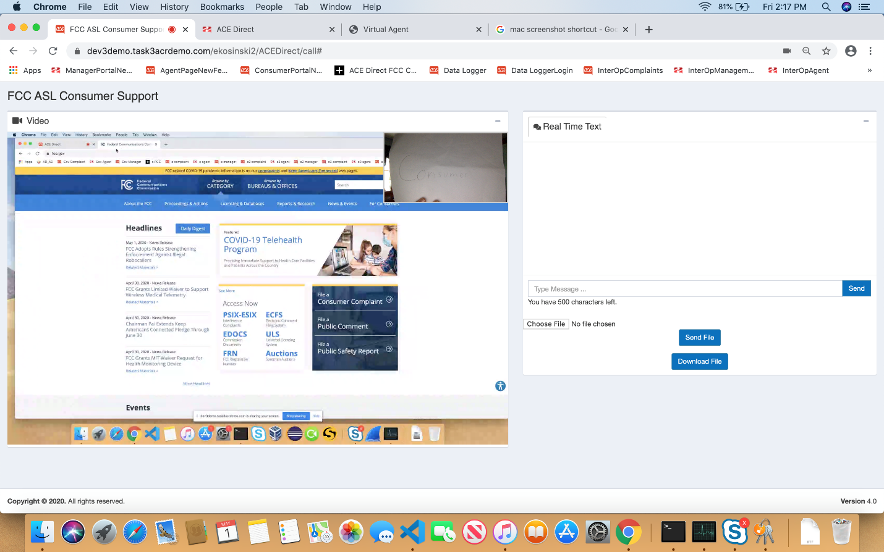

Figure 68. Screenshot of Consumer Screen Sharing

### Consumer File Sharing

ACE Direct supports file sharing between Agents and Customers.

#### Consumer Sending Files

Files can be shared between ACE Direct Agents and Consumers. To send a file, the Consumer clicks on the “Send File” button as shown in Figure 69 The Consumer then clicks the “Choose File” button to select the desired files. Consumers can share all types of files, including video (e.g., mp4). Each file must be sent individually.

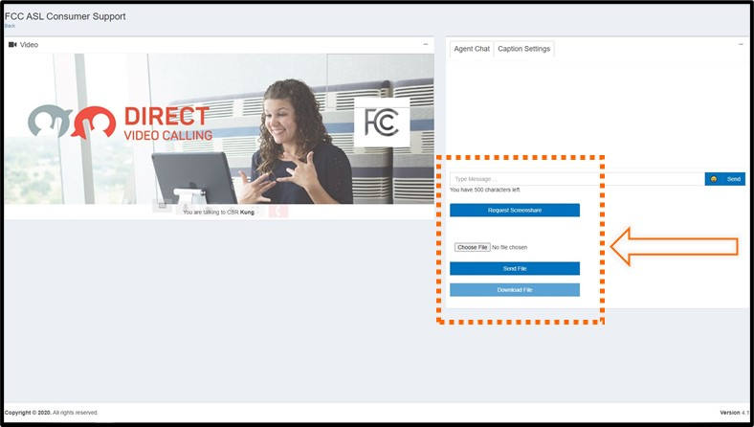

Figure 69. Consumer File Share Option

A File Explorer window will open for the Consumer to select a file. Once the file has been selected, then the Consumer clicks on the “Send File” button (Figure 70). A virus scanner scans each file before it is sent.

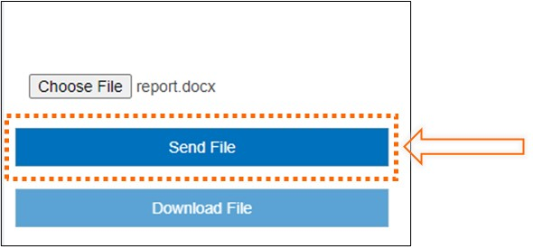

Figure 70. Consumer File Share Send File Option

Once the file has been sent successfully, the Consumer will receive a confirmation message (Figure 71).

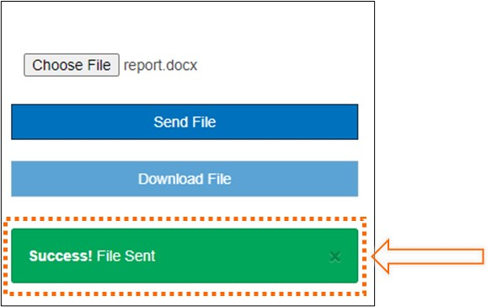

Figure 71. Consumer File Sent Confirmation Message

If the virus scanner flags the file or if there is another problem sending the file, the Consumer will receive an error message (Figure 72).

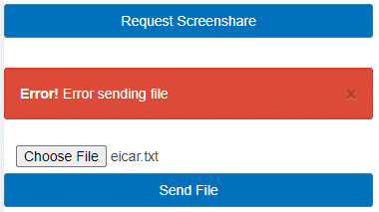

Figure 72. Consumer File Sent Error Message

#### Consumer Downloading Files

Consumers can download files from other Agents by double-clicking on the filename as shown in Figure 73 . Consumers can download all types of files, including video (e.g., mp4). Each file must be sent individually. After downloading the file, a confirmation is displayed.

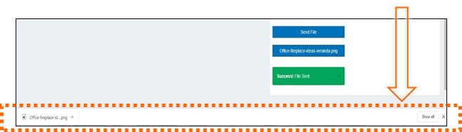

Figure 73. Screenshot of Consumer Download File and Confirmation Message

## Management Portal

The Management Portal consists of five main components: Management Dashboard, Call Detail Record Dashboard, Videomail Dashboard, Light Configuration page, and Hours of Operation page. These pages present the Manager with information about call center operations, call data metrics, videomail management, customizing colors associated with an Agent status on the Kuando Busylight (please refer to subsection 2.7), and managing the call center hours of operation.

### Management Dashboard

The Management Dashboard, as shown in Figure 74, provides KPIs for monitoring in real time. Follow these two steps to access the Management Dashboard:

* Start the browser on a machine that can access the Management Portal Node.js server.
* Enter a URL like https://<hostname>/ManagementPortal, where <hostname> is the host name of the Management Portal server. The exact URL depends on your installation and customization of ACE Direct.

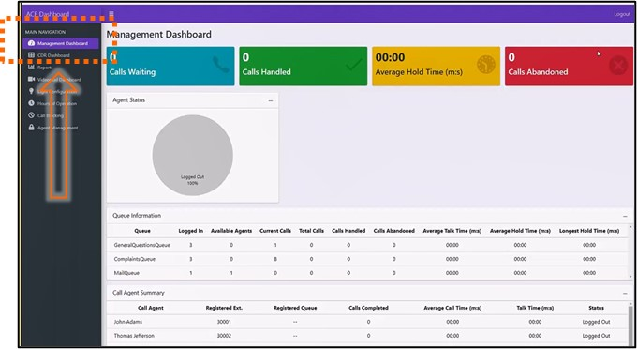

Figure 74. Screenshot of Management Dashboard

Key Performance Indicator Types

The ACE Direct Management Dashboard presents four types of KPIs:

1. **Summary Data** – The following KPIs provide insight into call center status data:
   1. Calls Waiting – Number of calls waiting in all queues.
   2. Calls Handled – Number of calls completed in all queues.
   3. Average Hold Time (minutes:seconds) – Average call holding time in all queues.
   4. Calls Abandoned – Number of calls not answered in all queues.
   5. Average Calls in Queue (chart) – Real-time chart of average calls in queue.
   6. Agent Status (chart) – Real-time chart of agents logged in/out.
2. **Queue-related KPIs** **–** The following KPIs provide insight into call center queues:
   1. Logged In – Number of Agents currently logged into the system.
   2. Available Agents – Number of Agents currently in a ready state.
   3. Current Calls – Number of calls currently in progress.
   4. Total Calls – Total number of calls made.
   5. Calls Handled – Total number of calls answered by an Agent.
   6. Calls Abandoned – Total number of calls abandoned.
   7. Talk Time – Average talk time (minutes:seconds).
   8. Hold Time – Average hold time (minutes:seconds).
   9. Longest Hold Time – The longest hold time (minutes:seconds).
3. **Agent-related KPIs** **–** The following KPIs are displayed per Agent. The Agent name, extension, and registered queues are displayed along with the KPI:
   1. Agent Name – Name of the Agent.
   2. Registered Extension – Extension assigned to the Agent.
   3. Registered Queues – Asterisk queues assigned to the Agent. All queue names are displayed if an Agent is assigned to more than one queue.
   4. Calls Completed – Number of calls handled (answered and completed) by the Agent.
   5. Average Call Time – Talk Time divided by number of calls.
   6. Talk Time – The cumulative time the Agent has spent on calls.
   7. Status – Logged Off, Ready, Away, or In-Call.
4. **Resource Status KPIs** – The following KPIs denote the resource status:
   1. Resources – A list of services required for ACE Direct to properly operate (ACE Direct, ACR-CDR, Agent Provider, Asterisk, VRS Lookup, and Zendesk).
   2. Status – The current state of each service (Running or Unavailable).

### Call Detail Record Dashboard

Asterisk generates an Agent event when a call is completed. A Call Detail Record contains metadata that describes each call, such as the time of the call, call source, and call destination (Figure 75). The CDR Dashboard provides the capability to audit call activity, track an Agent’s call activity, and report on incoming and outgoing calls. The CDR Dashboard facilitates viewing and exporting of Asterisk CDRs stored in the MySQL database.

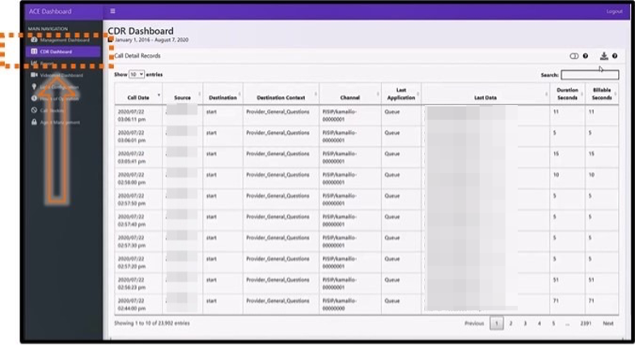

Figure 75. Screenshot of Call Detail Record

The CDR Dashboard allows the user to perform the following actions on the CDRs:

* **Select Date Range** – The Consumer can select a date range for the report. Predefined values are Today, Yesterday, Last 7 days, Last 30 days, This Month, Last Month, All Time (“Date of initial installation of ACE Direct” to “Today”), and Custom Range. The default selection is “Last 7 Days.”
* **Sort Column** – The Consumer can sort on any column by clicking the sort icon located next to each column name. To multi-sort columns, the Consumer depresses the shift key when selecting columns.
* **Show/Hide Columns** – This action expands/condenses the table to show/hide the following columns: Caller ID Text, Destination Channel, Disposition, Automatic Message Accounting (AMA) Flags, Account Code, User Field, Unique ID, Linked ID, Sequence, and Peer Account.
* **Download CSV File** – This action downloads the table as a Comma Separated Value (CSV) file. The CSV file contains only data within the date range.
* **Search** – The user can search the entire table. Search results are displayed in near real time.

Table 7 presents the Call Detail Record Column Definitions in the CDR table.

Table 7. Call Detail Record Column Definition

| Display Name | Database Column | Description |
| --- | --- | --- |
| Call Date | Calldate | The start datetime of the call. Default format: 2016-09-07T09:35:41Z. The dashboard formats the date to 2016/09/07 09:35:41 pm (adjusted for time zone). |
| Caller ID Text | Clid | The full consumer ID, including the name, of the calling party. This field is set automatically and is read-only. |
| Source | Src | The calling party’s caller ID number. It is set automatically and is read only. |
| Destination | Dst | The destination extension for the call. This field is set automatically and is read only. |
| Destination Context | Dcontext | The destination context for the call. This field is set automatically and is read only. |
| Channel | Channel | The calling party’s channel. This field is set automatically and is read only. |
| Destination Channel | Dstchannel | The called party’s channel. This field is set automatically and is read only. |
| Last Application | Lastapp | The last dialplan application that was executed. This field is set automatically and is read only. |
| Last Data | Lastdata | The arguments passed to the lastapp. This field is set automatically and is read only. |
| Duration Seconds | Duration | The number of seconds between the start and end times for the call. This field is set automatically and is read only. |
| Billable Seconds | Billsec | The number of seconds between the answer and end times for the call. This field is set automatically and is read only. |
| Disposition | Disposition | An indication of what happened to the call. This may be NO ANSWER, FAILED, BUSY, ANSWERED, or UNKNOWN. |
| AMA Flags | Amaflags | The AMA flag associated with this call. This may be one of the following: OMIT, BILLING, DOCUMENTATION, or Unknown. |
| Account Code | accountcode | An account ID. This field is user defined and is empty by default. |
| User Field | Userfield | A general-purpose user field. This field is empty by default and can be set to a user-defined string. |
| Unique ID | Uniqueid | The unique ID for the src channel. This field is set automatically and is read only. |
| Linked ID | Linkedid | A unique identifier that unites multiple CDR records. |
| Sequence | Sequence | A numeric value that, combined with uniqueid and linkedid, can be used to uniquely identify a single CDR record. |
| Peer Account | peeraccount | The account code of the called party’s channel |

### Agent Report

Agents can create reports with call data such as Call Summary Reports from the Agent Management portal. Figure 76 presents an Agent Management report option.

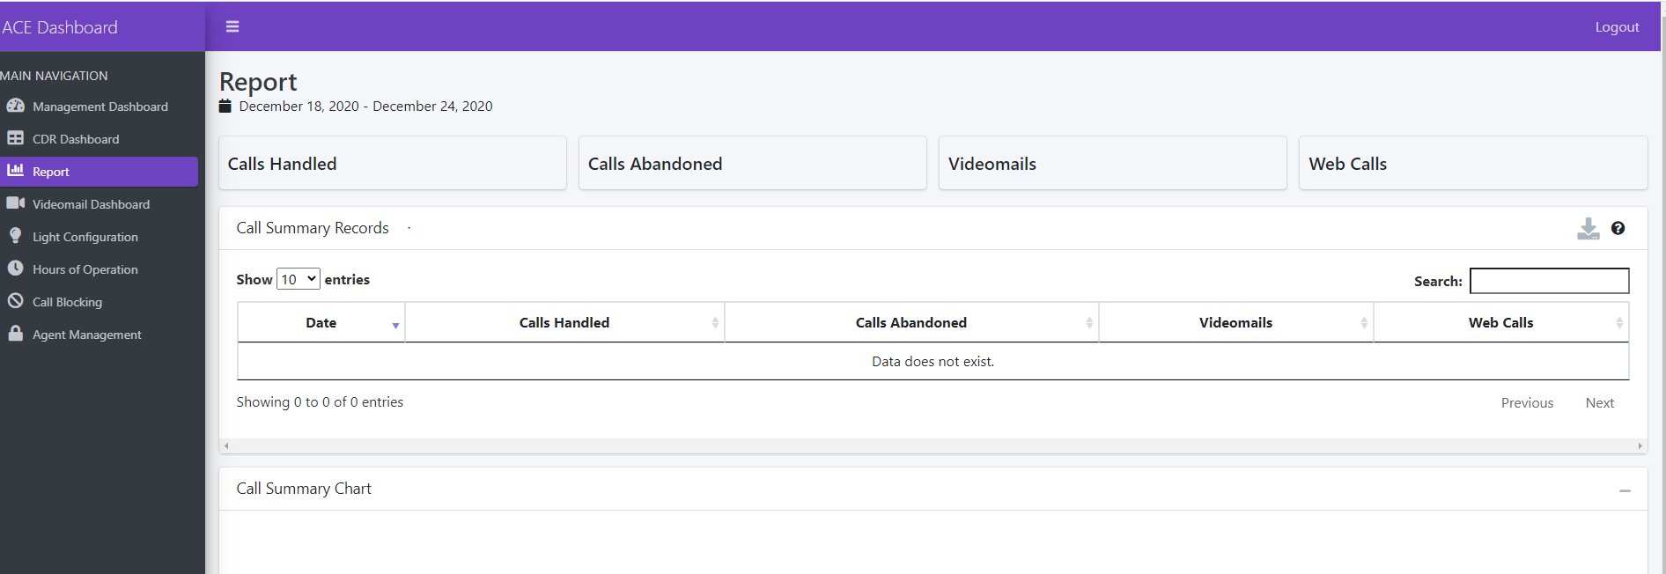

Figure 76. Agent Management Report Option

The Agent can select a date range from a dropdown menu for the report call data as shown in Figure 77. The preselected date range options are “Today,” “Yesterday,” Last 7 days,” “Last 30 Days,” “This Month,” “Last Month,” “All Time,” and “Custom Range.”

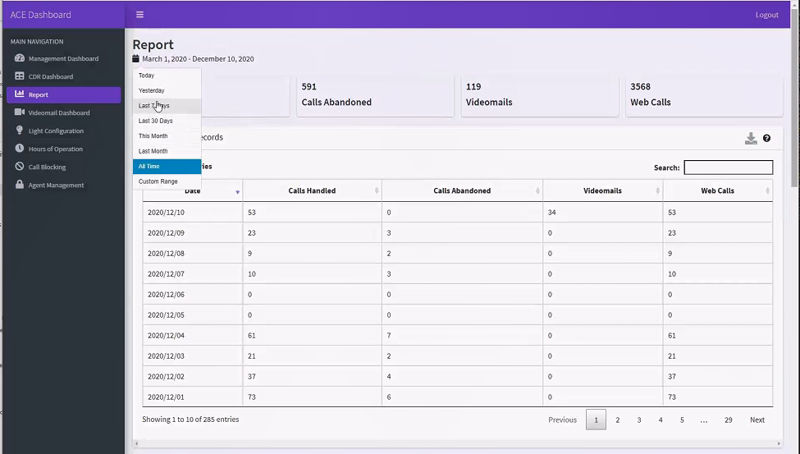

Figure 77. Agent Management Report Date Selection

If the Agent selects the “Custom Range” option, a calendar is displayed (Figure 78). After selecting the desired date range, the Agent clicks, “Apply.”

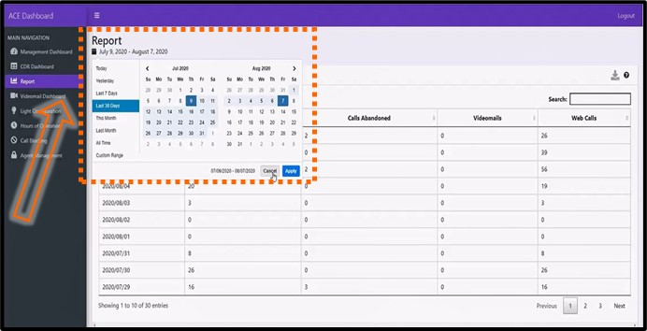

Figure 78. Agent Management Custom Report Option

The Agent can review the top 10 states, top 10 area codes and Top 10 VRS numbers in the call data as depicted in Figure 79.

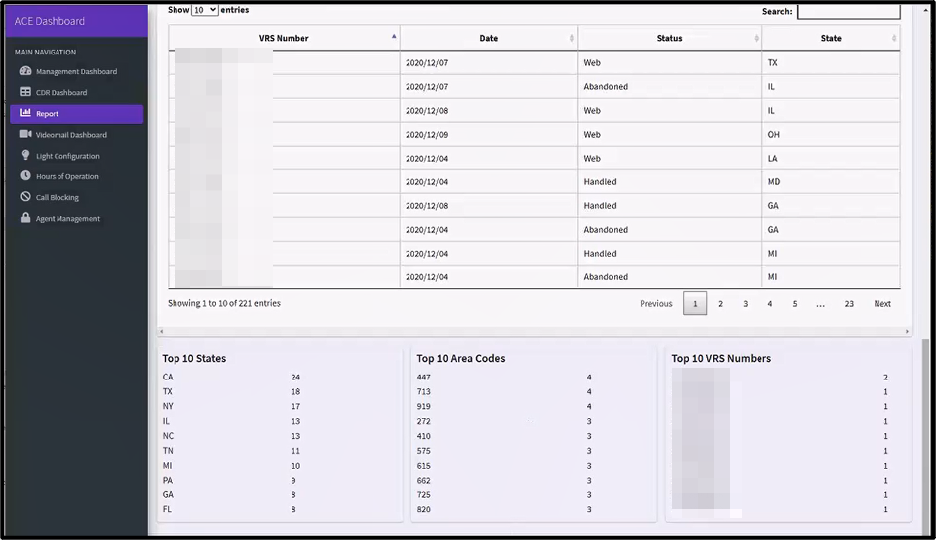

Figure 79. Top Ten Report View

### Videomail Dashboard

The Videomail Dashboard, as shown in Figure 80, allows the Manager to track videomail-related information. It shows all videomails that are present in the Agent Portal, along with the date received, Agent(s) who viewed and processed the videomail, caller videophone number, and videomail status. If an Agent deletes the videomail, the status will show “Marked for Deletion,” at which point the Manager can review it and choose whether to permanently delete it. If the Manager does not delete the videomail, then the videomail is permanently deleted after 14 calendar days. These rules can be configured to meet an agency’s data retention rules.

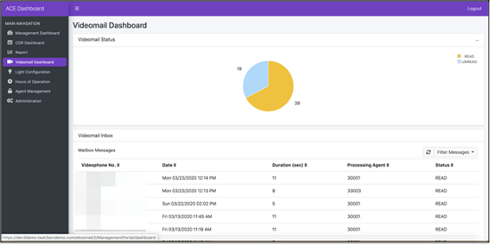

Figure 80. Screenshot of Videomail Dashboard

### Hours of Operation

The Hours of Operation page, as shown in Figure 81, allows the Manager to control the operating hours of ACE Direct. The page displays the call center hours of operations for each time zone. A Manager can select Open and Close times for the call center. The Manager also has the option to override the duty hours with an Always Open or Always Closed option. These override options can be used in the case of an emergency closure or holiday. A Consumer who accesses the ACE Direct Consumer Portal outside of the operating hours will be presented with a message advising that the call center is closed.

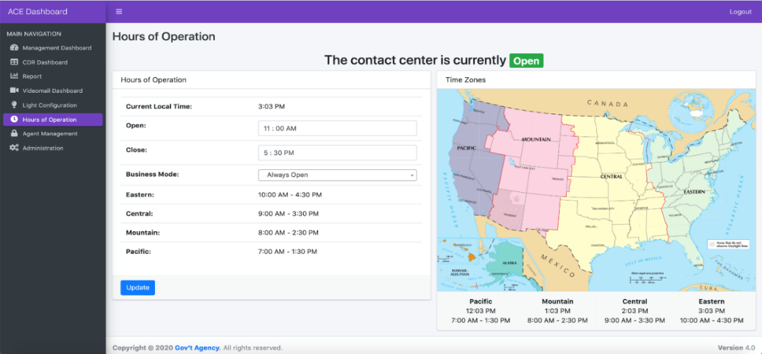

Figure 81. Screenshot of Hours of Operation Page

### Call Blocking

Managers can block incoming calls by clicking on Call Blocking from the Management Portal. To perform this option, Managers click on ‘Add New Call Block’ as depicted in Figure 82.

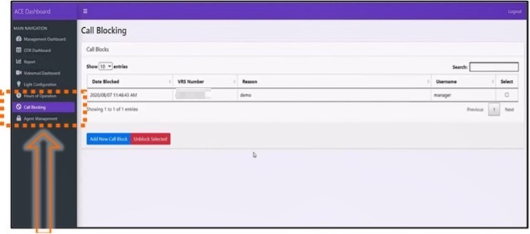

Figure 82. Call Blocking Menu

#### Blocking a Call

When the Agent initiates call blocking, the “Call Block Information” screen will be displayed as shown in Figure 83. To initiate the call block process, the Manager will click “Add Call Block.”

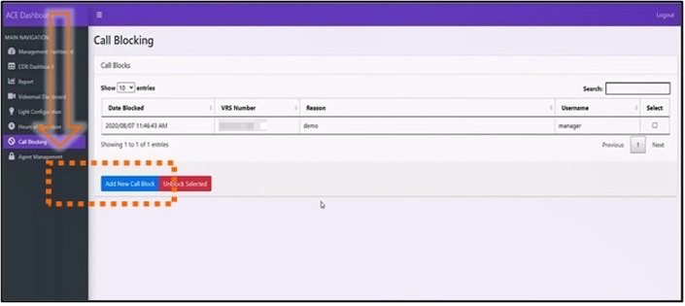

Figure 83. Blocking a Call

Figure 84 shows the display of the “Call Block Information” popup. The Manager enters the 10-digit phone number to block and an optional Reason, then clicks “Add Call Block” to add the phone number to the blocked call list.

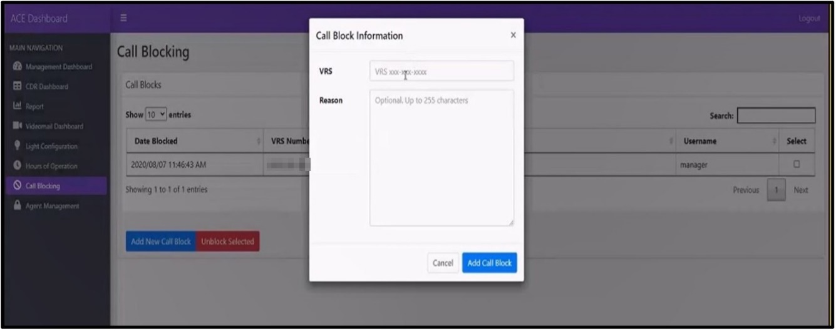

Figure 84. Call Blocking Information Pop-Up Menu

#### Unblocking a Call

To unblock a VRS number, Managers will click on the desired phone number in the “Call Blocking” menu, then click “Unblock Selected” (Figure 85).

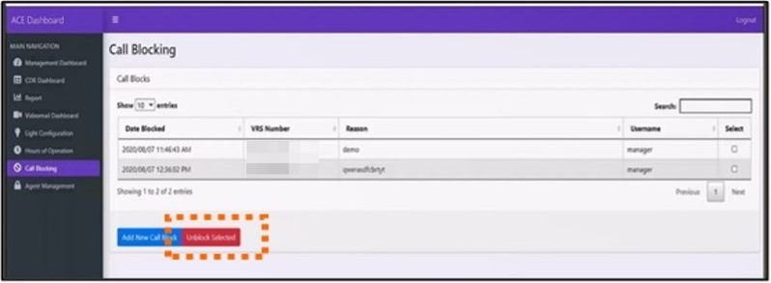

Figure 85. Unblocking a Phone Number

After entering the information to unblock a phone number, the confirmation message depicted in Figure 86 will be displayed.

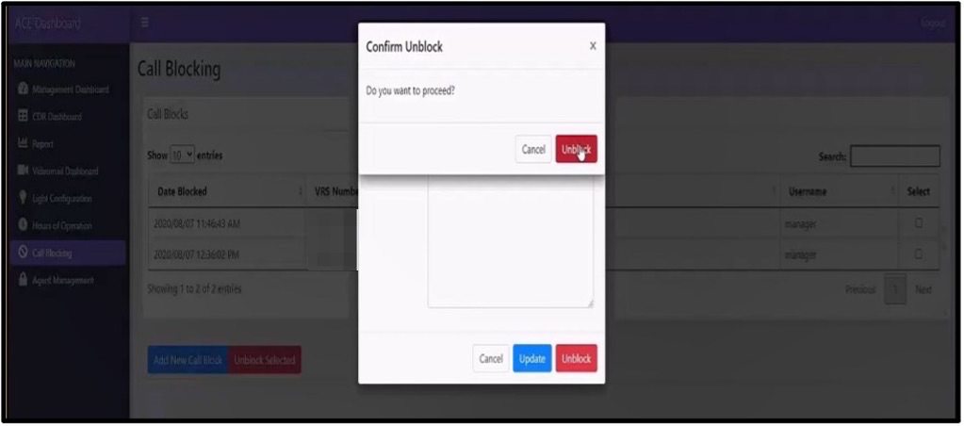

Figure 86. Unblocking a Call Confirmation Message

Managers are also able to update information about the blocked VRS telephone number such as the Reason by clicking on “Update” (Figure 87).

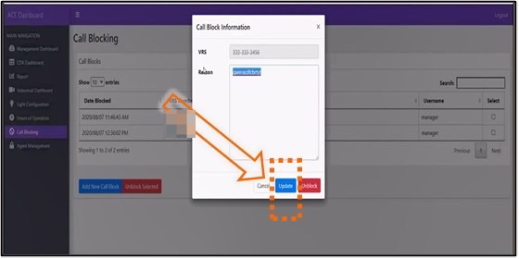

Figure 87. Update Blocked Call Pop-Up

### Agent Management

The Agent Management page allows the Manager to add/delete/update Agents. The Manager can load the page by selecting “Agent Management” from the side panel of the Management Portal, which lists the existing Agents configured in the system as shown in Figure 88. The Manager may set the number of Agents to be displayed in a single page and sort Agents based on their name, username, and extension assigned.

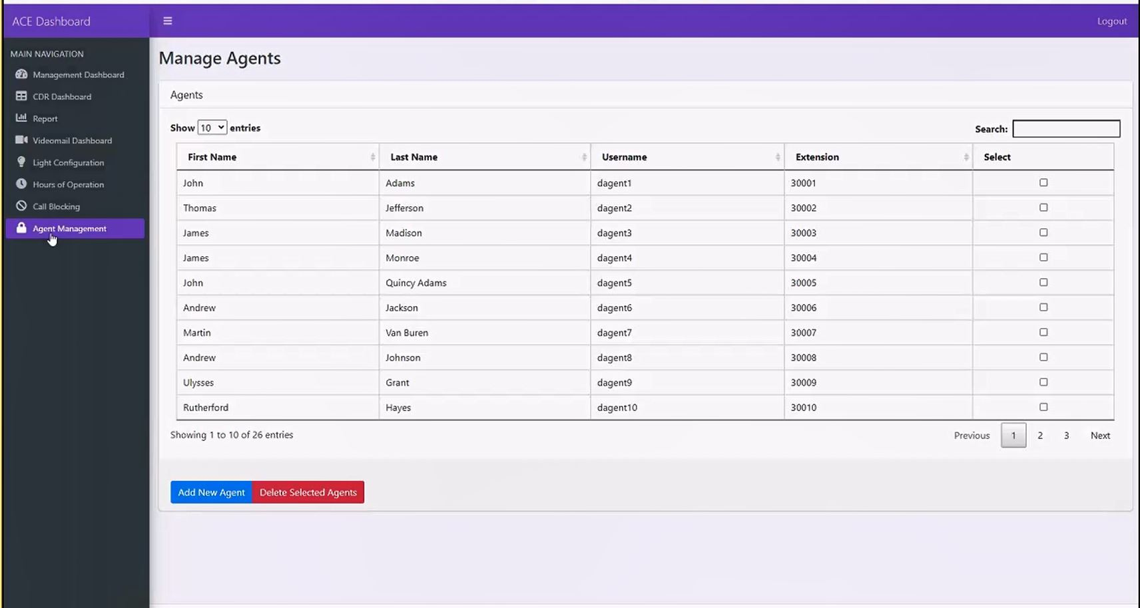

Figure 88. Screenshot of Agent Management Page

#### Add a New Agent

A Manager can add a new Agent by clicking the “Add New Agent” button at the bottom of the Agent Management page. Figure 89 illustrates the required information for entry. ACE Direct checks the proper data format before a new Agent is created. The system prompts the Manager to fix any incorrect data input.

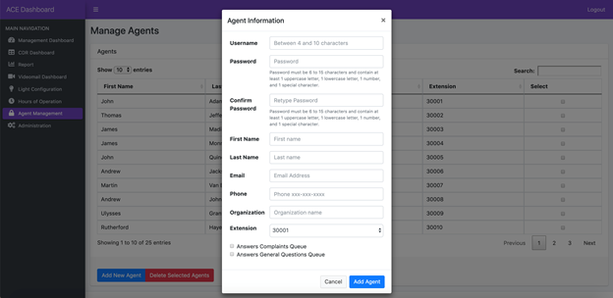

Figure 89. Screenshot of Add New Agent Pop-Up

#### Update an Existing Agent

A Manager can update the Agent information by clicking on any existing Agent record. Figure 90 illustrates the Agent update pop-up. Note that Agent username and password are grayed out and not available for updating. The Manager may also delete the Agent record on the same pop-up.

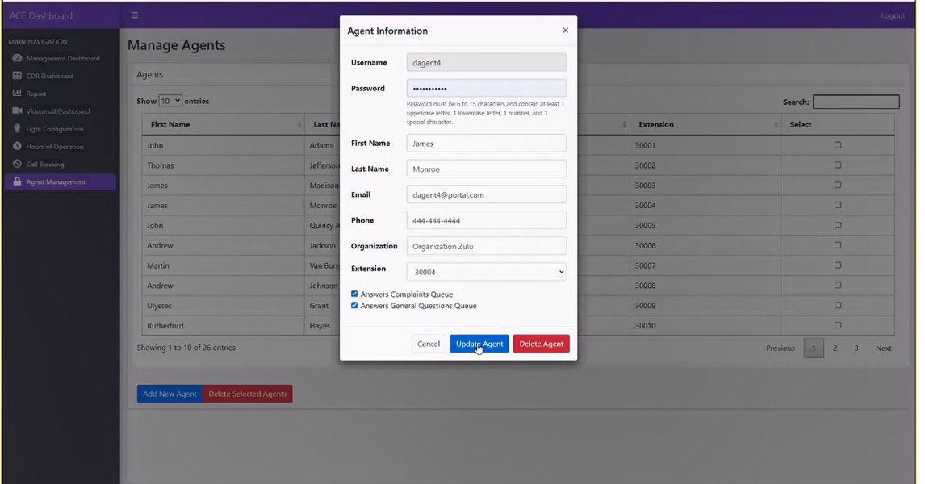

Figure 90. Screenshot of Update Agent Pop-Up

#### Bulk Delete Selected Agents

The Manager may select a group of Agent records and delete them by first selecting multiple Agents from the “Select” column and then clicking on the “Delete Selected Agent” button at the bottom of the Agent Management page. The system will prompt the user to confirm the deletion as illustrated in Figure 91.

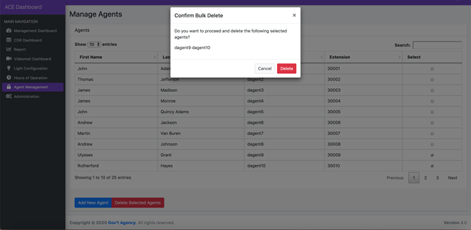

Figure 91. Screenshot of Agent Bulk Deletion Pop-Up

## Identity and Access Management

ACE Direct integrates with ForgeRock OpenAM, an open-source identity and access management enterprise solution that provides user management and access control capabilities. The ForgeRock OpenAM and embedded OpenDJ are the only ForgeRock packages used in ACE Direct.

ACE Direct users, such as Managers and Supervisors, must be provisioned in OpenAM before they can access the Management, Agent, or Consumer portals. To provision Agents, use the Agent Management feature on the Management Portal, although the password management functionalities may be used after Agent creation.

Provisioning instructions to create new roles can be found in Provision.md under <https://github.com/FCC/ACEDirect> in the “iam” section.

There are two ways a user authenticates with the Agent or Management portals:

1. **ACE Direct URL** – The user accesses ACE Direct directly by entering the ACE Direct URL. If the user is already authenticated with ACE Direct and the session is still valid, the Agent Portal is displayed; if not, the user is redirected to the Main login page to authenticate. The Agent Portal is displayed after a successful login.

**An OpenAM Login URL (Main login page)** – This is the main login page for a user to authenticate, reset the password, or create a new account. After logging in, the user selects the application to access as listed on the dashboard.

The following subsections describe the identity and access management capabilities in detail.

### Login Screen

Figure 92 shows the login screen.

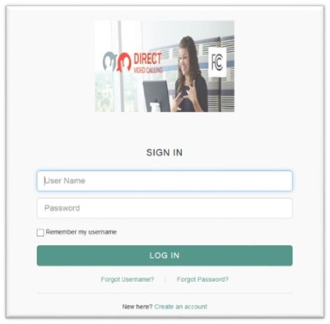

Figure 92. Screenshot of Login Screen

The login screen consists of the following elements:

1. **Login** – User provides login credentials (username, password) to authenticate to ACE Direct.
2. **Forgot Username** – Redirects the user to the “Forgot Username” page to retrieve username.
3. **Forgot Password** – Redirects the user to the “Forgot Password” page to reset password.

**Self-Registration** – Allows the user to self-register and create an account.

#### Forgot Username

A user clicks the “Forgot Username” link to retrieve a forgotten username. The following “Retrieve Your Username” screen is displayed as shown in Figure 93.

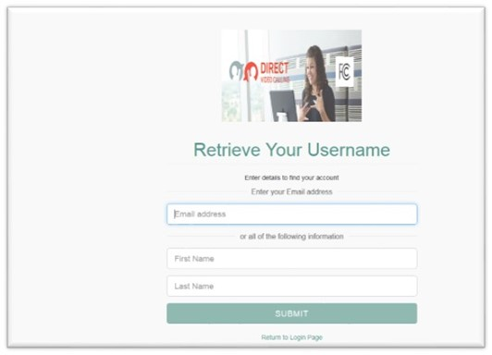

Figure 93. Screenshot of Retrieve Your Username

A user may retrieve their username via:

* **Email** – If the user entered his/her email on the reset username screen.
* **Answering security questions** – The user is prompted with security questions after he/she submits First Name/Last name on the retrieve username screen. If the user answers the security questions correctly, the screen displays the user’s dashboard.

#### Forgot Password

Figure 94 shows the “Reset Your Password” screen displayed when the user clicks the “Forgot Password” link to reset password.

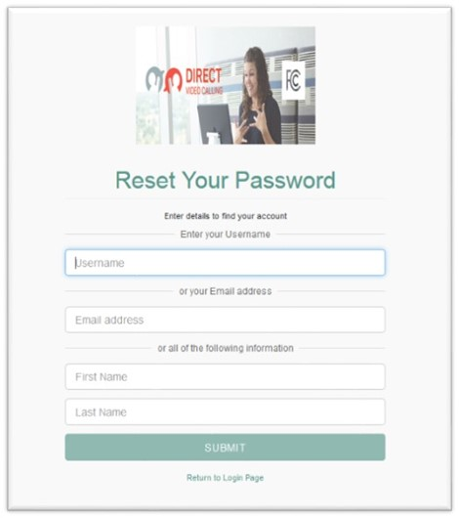

Figure 94. Screenshot of Reset Your Password

Users may reset the password via email or by answering security questions:

* **Email** – If the user entered his/her email on the reset password screen.
* **Answering security questions** – The user is prompted with security questions after he/she submits username or First Name/Last name on the reset password screen. If the user answers the security questions correctly, the screen displays the user’s dashboard.

#### Self-Registration

It is recommended that the Administrator use the Agent Management feature on the Management Portal to create/update/delete an Agent. Any person can self-register and create an account to become a user; however, that account is not activated until the Administrator activates the user account. To create such a user account, the self-registering person clicks the “Create an account” link at the bottom of the login page as shown in Figure 95. The “Register Your Account” screen will pop up, allowing the new user to enter his or her email address and submit the registration request. An email will be sent to the user’s email address to continue and complete the creation of the account.

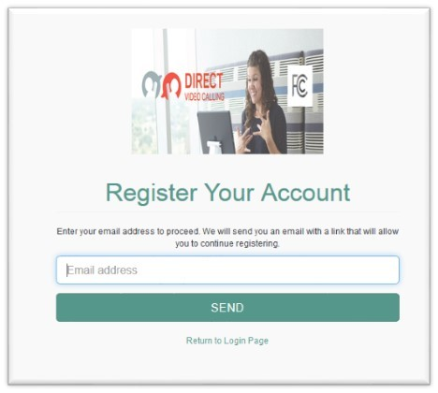

Figure 95. Screenshot of Register Your Account

### User Dashboard

Figure 96 shows the User Dashboard page after the user is authenticated with the Main login page.

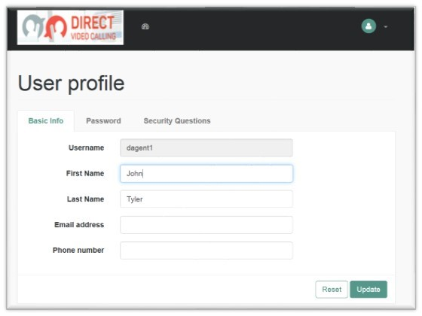

Figure 96. Screenshot of User Dashboard

The User Dashboard page consists of the following sections:

* User profile
  + Basic Info
  + Password
  + Security Questions
* Dashboard
* Logout

#### User Profile

##### Basic Info

Figure 97 shows the Basic Info tab on the User profile screen.

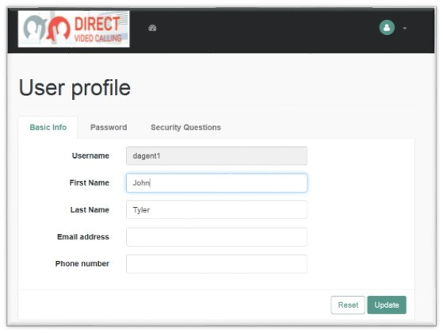

Figure 97. Screenshot of Basic Info Tab

The user views or updates his/her first name, last name, email address, or phone number on this page and clicks “Update” to save the changes.

##### Password

Figure 98 shows the Password tab on the User Profile screen. The user updates his or her password from this screen. To change the password, the user clicks on the Password tab and clicks “Update” to save changes.

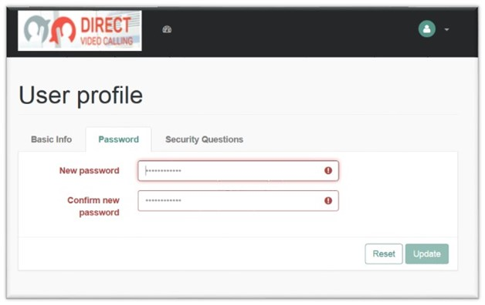

Figure 98. Screenshot of Update Password Tab

##### Security Questions

Figure 99 shows the Security Questions tab on the User Profile screen. A user may retrieve his/her password via email by answering security questions. This screen allows the user to add security questions to retrieve a forgotten password by email.

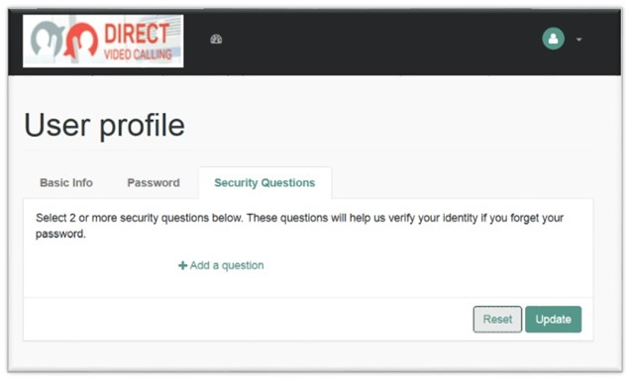

Figure 99. Screenshot of Security Questions Tab

The user must provide at least two security questions for this purpose. To accomplish this, the user must:

* Select the “Security Questions” tab.
* Select a pre-defined security question or create a new security question.
* Provide an answer to the question.
* Repeat the process for at least one additional security question.
* Click “Update” to save the changes.

#### Dashboard

The Dashboard is an area where the user views the list of applications approved for his/her access. Figure 100 shows an example of an Agent’s dashboard and a list of approved applications under the My Application dropdown.

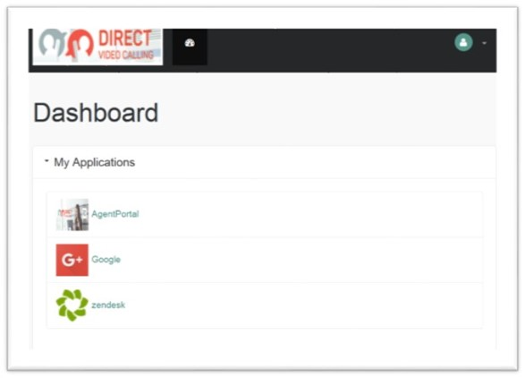

Figure 100. Screenshot of User Dashboard

#### Logout

To log out from the Main Login page and all open sessions to reach the Agent and/or Management Portal, select “LOG OUT” from the dropdown list at the top right corner of the page as shown in Figure 101.

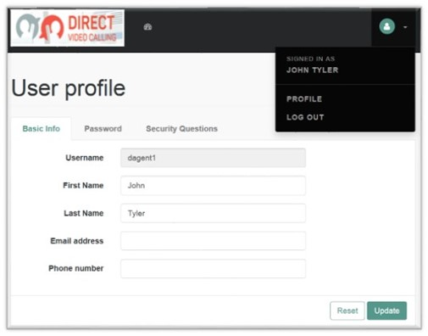

Figure 101. Screenshot of Logout Screen

Acronyms

| Term | Definition | |
| --- | --- | --- |
| ACE | Accessible Communications for Everyone | |
| ADA | Americans with Disabilities Act | |
| AMA | Automatic Message Accounting | |
| API | Application Programming Interface | |
| ASL | American Sign Language | |
| AWS | Amazon Web Services | |
| CA | Communication Assistant, Certificate Authority | |
| CDC | Change Data Capture | |
| CDR | Call Detail Record | |
| CMS | Centers for Medicare & Medicaid Services | |
| COE | Center of Expertise | |
| COTS | Commercial Off-the-Shelf | |
| CRM | Customer Relationship Management | |
| CSR | Customer Service Representative | |
| CSV | Comma Separated Value | |
| DB | database | |
| DDoS | Distributed Denial of Service | |
| DVC | Direct Video Calling | |
| ENUM | E.164 Number to URI Mapping | |
| ESB | Enterprise Service Bus | |
| FCC | Federal Communications Commission | |
| FFRDC | Federally Funded Research and Development Center | |
| GUI | Graphical User Interface |
| HHS | Department of Health and Human Services | |
| HSTS | HyperText Transfer Protocol Strict Transport Security | |
| HTTP | HyperText Transfer Protocol | |
| HTTPS | HyperText Transfer Protocol Secure | |
| IADM | Identity and Access Management | |
| IP | Internet Protocol | |
| iTRS | Interstate Telecommunications Relay Service | |
| JSON | JavaScript Object Notation | |
| KPI | Key Performance Indicator | |
| NAT | Network Address Translation | |
| NAT | Network Address Translation | |
| **NGINX** | A web server that can also be used as a reverse proxy, load balancer, mail proxy, and HTTP cache | |
| **OpenAM** | Open Access Management | |
| **OpenIDM** | Open Identity Management | |
| PBX | Private Branch Exchange | |
| POC | Proof of Concept | |
| PSTN | Public Switched Telephone Network | |
| REST | Representational State Transfer | |
| RFC | Request for Comment | |
| RTT | Real-Time Text | |
| SIP | Session Initiation Protocol | |
| STUN | Session Traversal Utilities for NAT | |
| TLS | Transport Layer Security | |
| TRS | Telecommunications Relay Service | |
| UDP | User Datagram Protocol | |
| UI | User Interface | |
| URI | Uniform Resource Identifier | |
| URL | Universal Resource Locator | |
| VRS | Video Relay Service | |
| WebRTC | Web Real-Time Communication | |

Notice

This (software/technical data) was produced for the U. S. Government under Contract Number 75FCMC18D0047, and is subject to Federal Acquisition Regulation Clause 52.227-14, Rights in Data-General.

No other use other than that granted to the U. S. Government, or to those acting on behalf of the U. S. Government under that Clause is authorized without the express written permission of The MITRE Corporation.

For further information, please contact The MITRE Corporation, Contracts Management Office, 7515 Colshire Drive, McLean, VA 22102-7539, (703) 983-6000.

**© 2021 The MITRE Corporation.**

1. MITRE is using d/Deaf as an umbrella term to describe individuals who are deaf in the audiological sense, as well as those who identify as culturally Deaf.
2. <https://www.fcc.gov/ace>
3. Available at: <https://www.fcc.gov/document/fcc-adds-american-sign-language-consumer-support-line-videophone>.